<https://www.youtube.com/watch?v=ctmNq7FgbvI&list=PLblh5JKOoLUICTaGLRoHQDuF_7q2GfuJF&index=23>

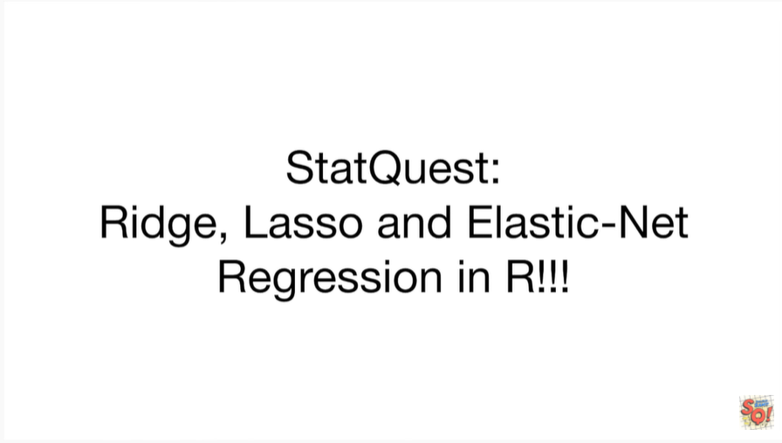

Today we're going to talk about Ridge, lasso and elastic net regression in R.

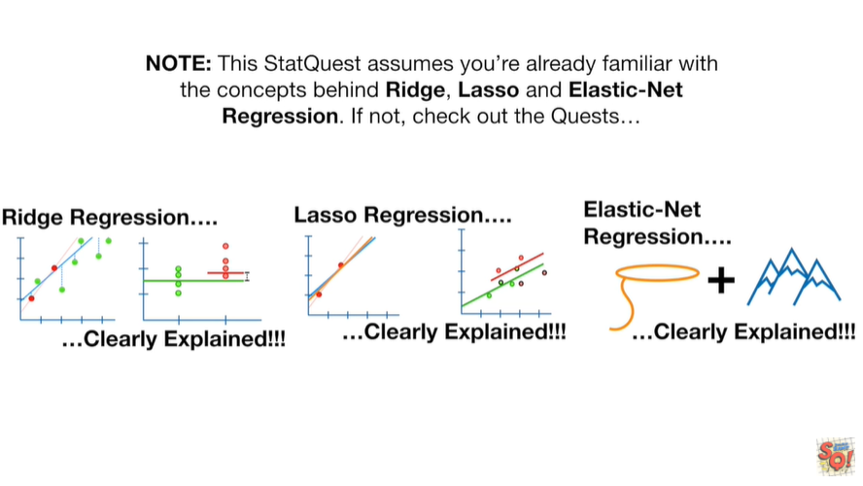

Note : this stack quest assumes you're already familiar with the concepts behind Ridge lasso in elastic net regression if not check out the quests.



To do Ridge lasso an elastic net regression and our we will use the glmnet library.

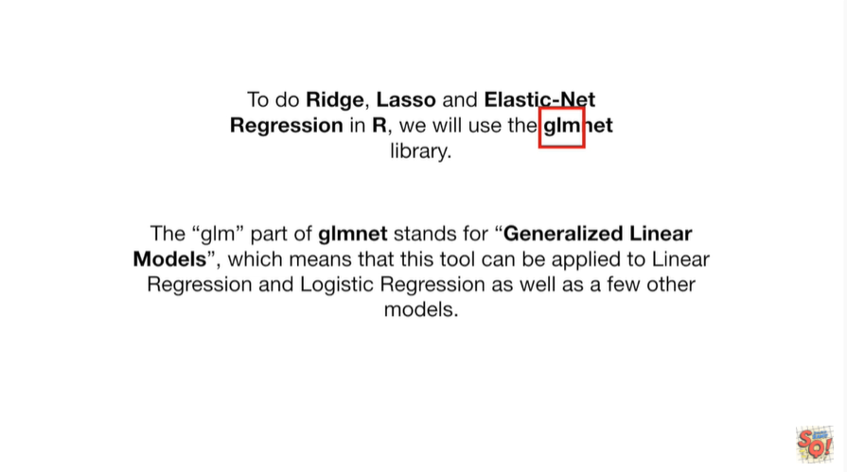

The glm part of gmlnet stands for generalized linear models which means that this tool can be applied to linear regression and logistic regression as well as a few other models.

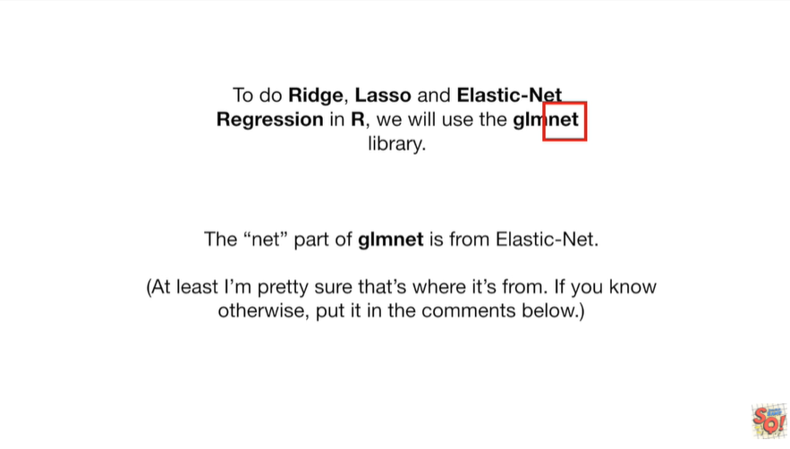

The net part of glmnet is from elastic net.

At least I'm pretty sure that's where it's from if you know otherwise, put it in the comments below.

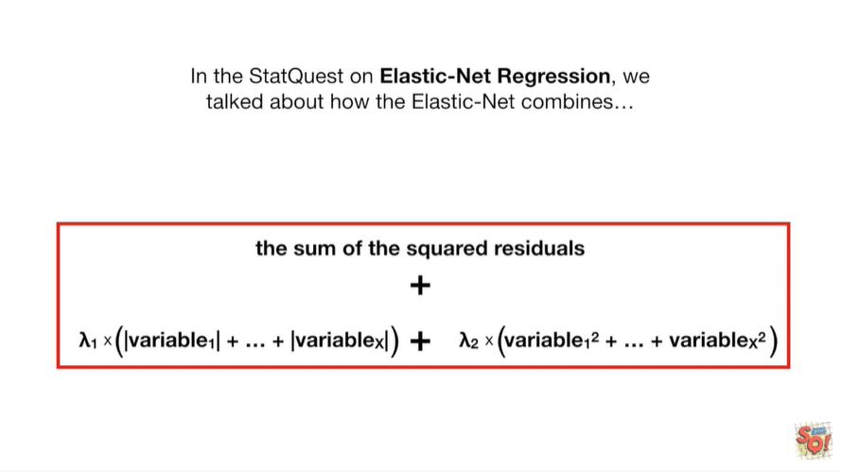

In the stat quest on elastic net regression we talked about how the elastic net combines

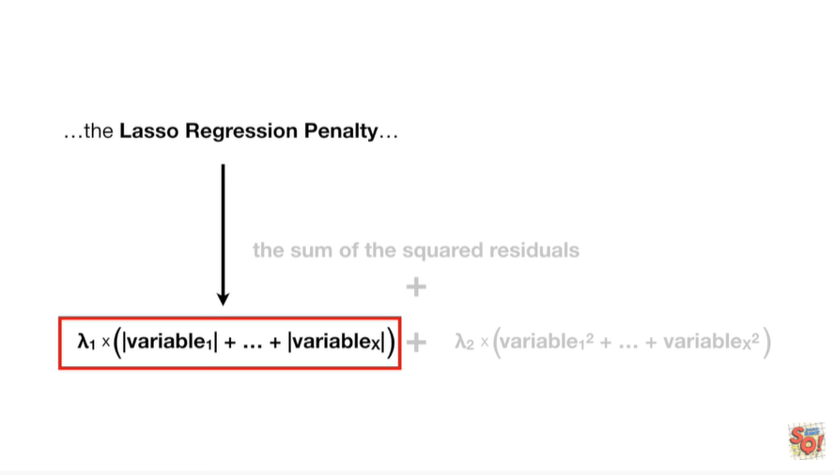

the lasso regression penalty Yi how

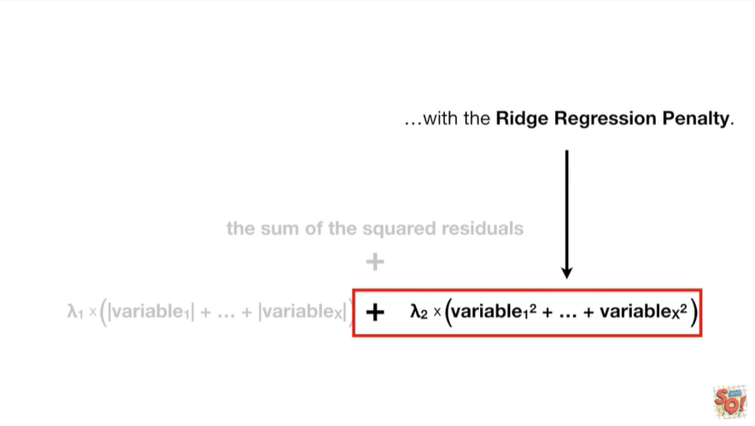

with the ridge regression penalty Brrr

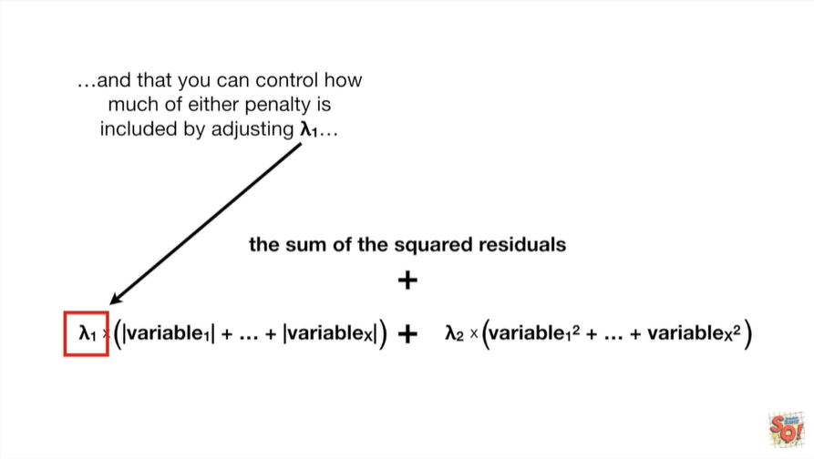

and that you can control how much either penalty is included by adjusting lambda sub 1

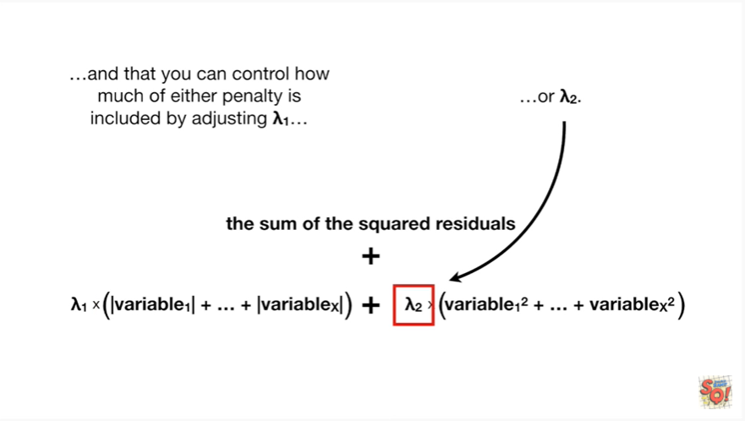

or lambda sub 2.

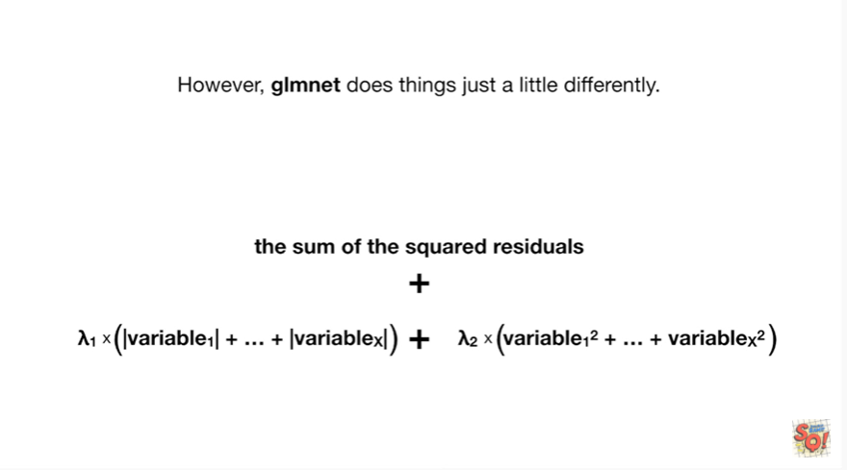

However glmnet does things just a little differently.

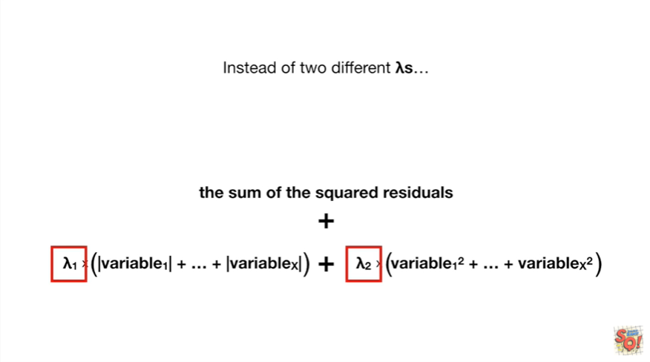

Instead of two different lambdas

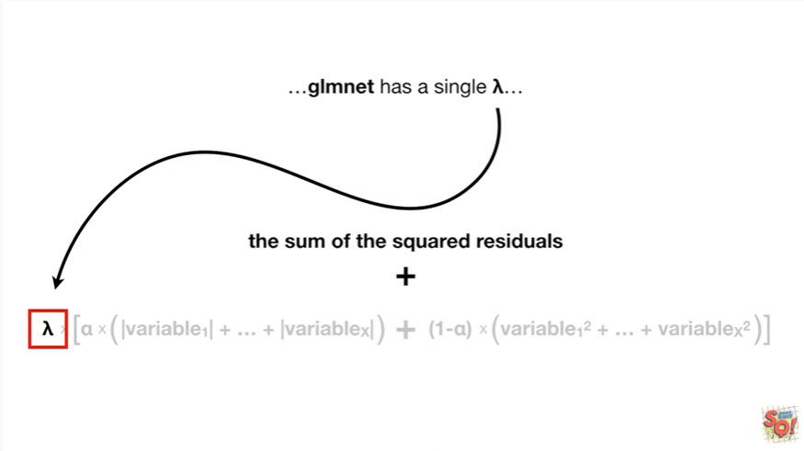

glmnet has a single lambda

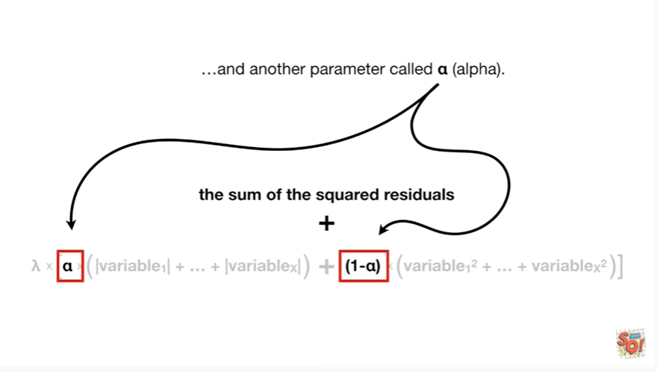

and another parameter called alpha

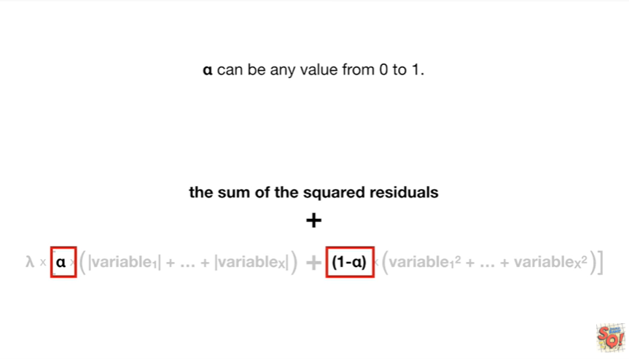

alpha can be any value from zero to one.

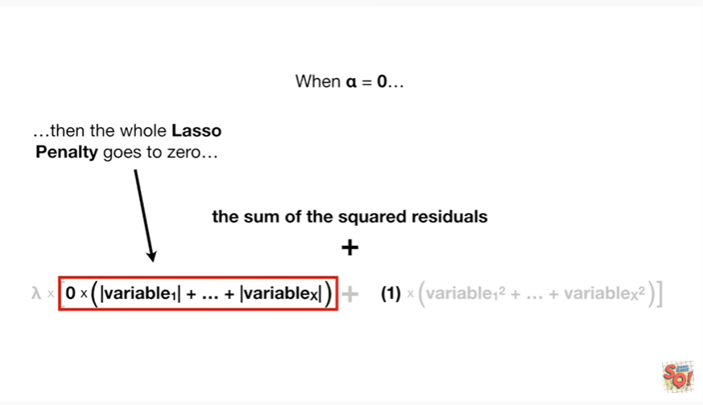

When alpha equals zero then the whole lasso penalty goes to zero

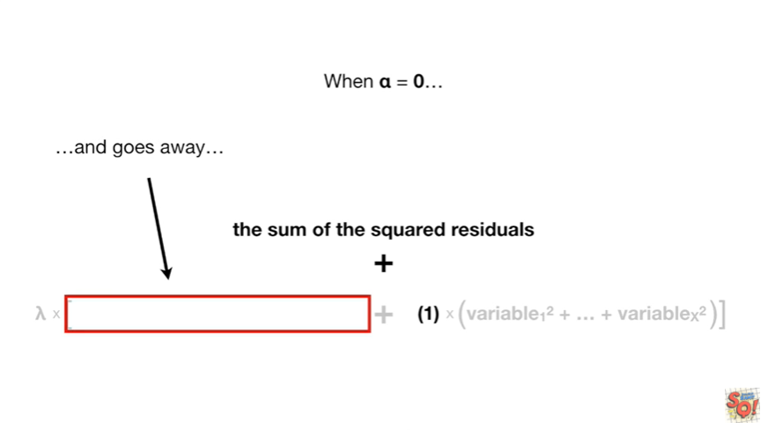

and goes away

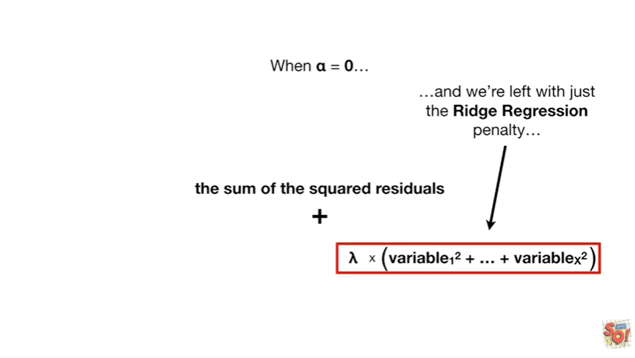

and we're left with just the ridge regression penalty

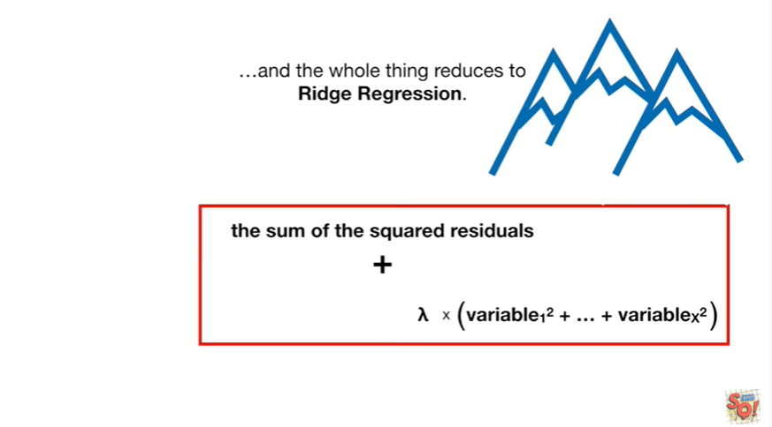

and the whole thing reduces to Ridge regression.

Burr.

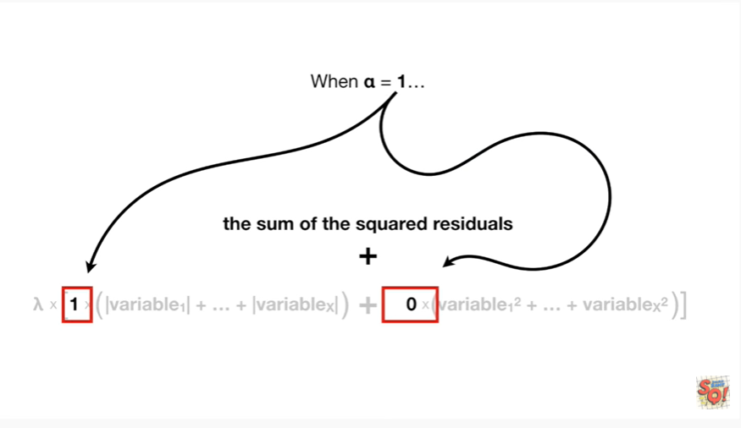

When alpha equals 1

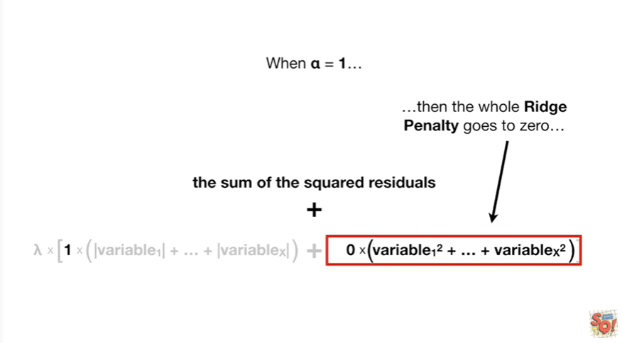

then the whole Ridge penalty goes to 0

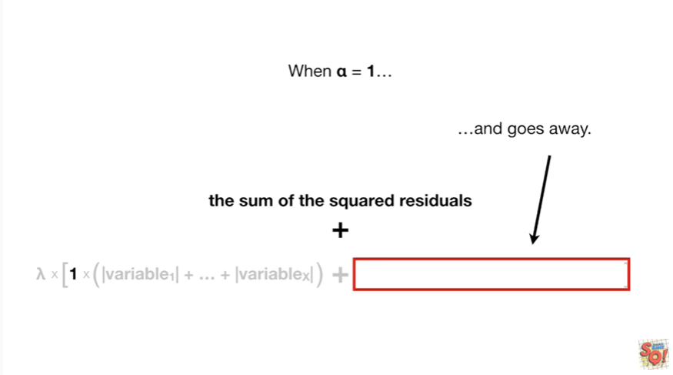

and goes away

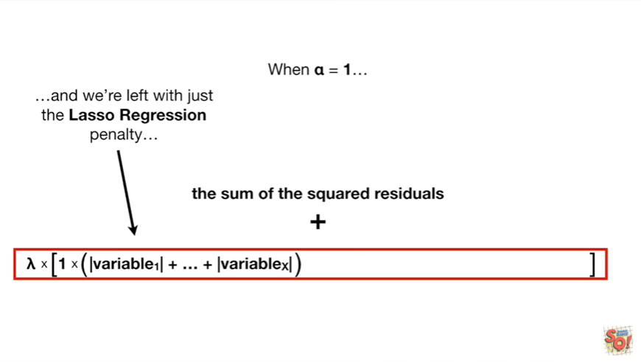

and w’re left with just the lasso regression penalty

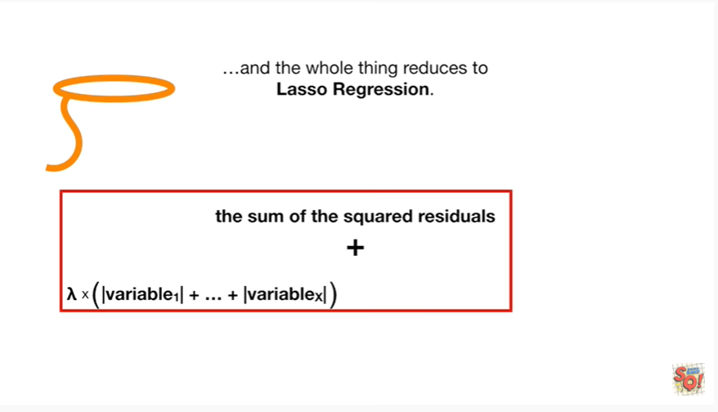

and the whole thing reduces to lasso regression.

Yeehaw.

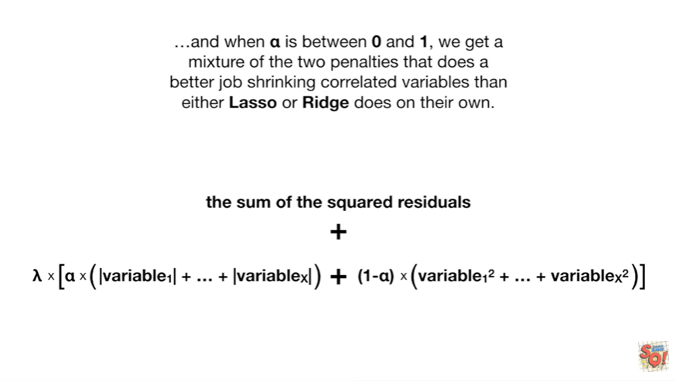

And when alpha is between 0 & 1 we get a mixture of the two penalties that does a better job shrinking correlated variables than either lasso or Ridge does on their own.

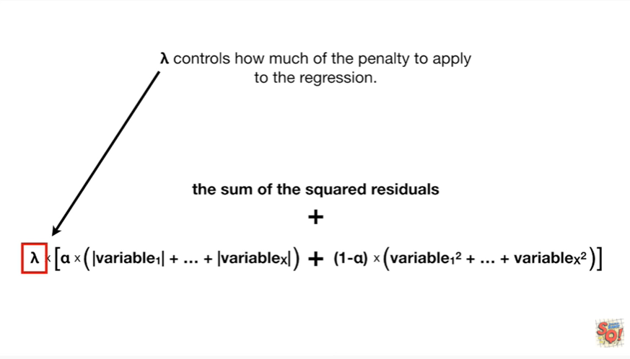

Lambda controls how much of the penalty to apply to their regression

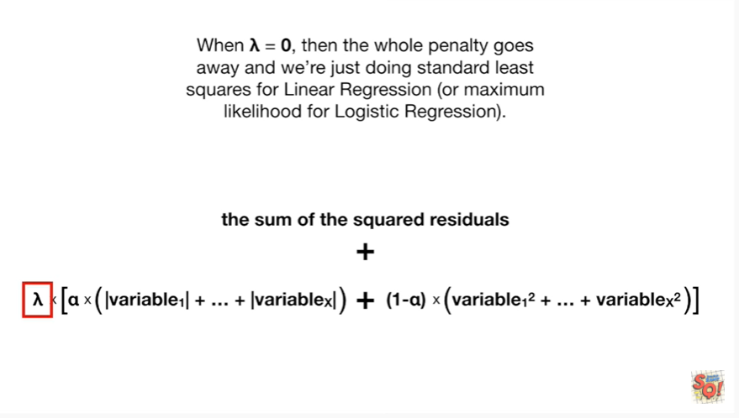

when lambda equals zero then the whole penalty goes away and we're just doing standard least squares for linear regression or maximum likelihood for logistic regression.

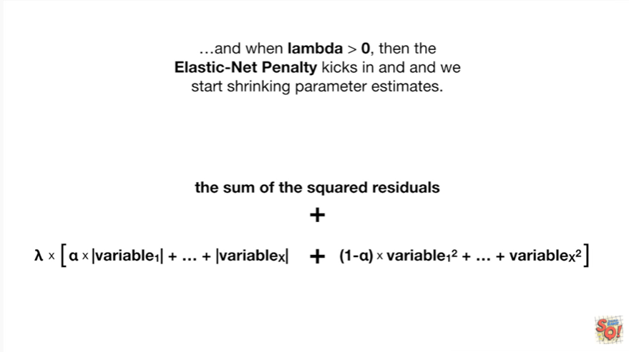

And when lambda is greater than zero then the elastic net penalty kicks in and we start shrinking parameter estimates.

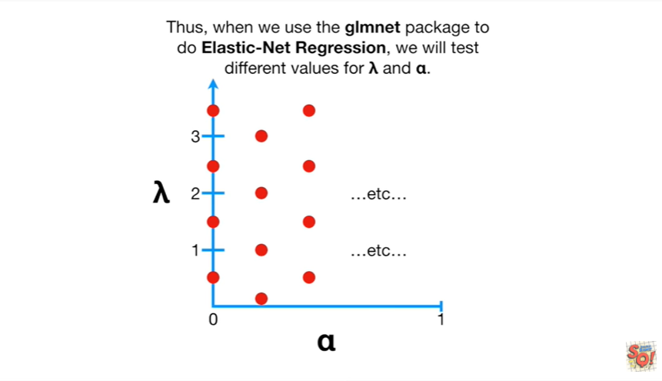

Thus when we use the glmnet package to do elastic net regression, we will test different values for lambda and alpha.

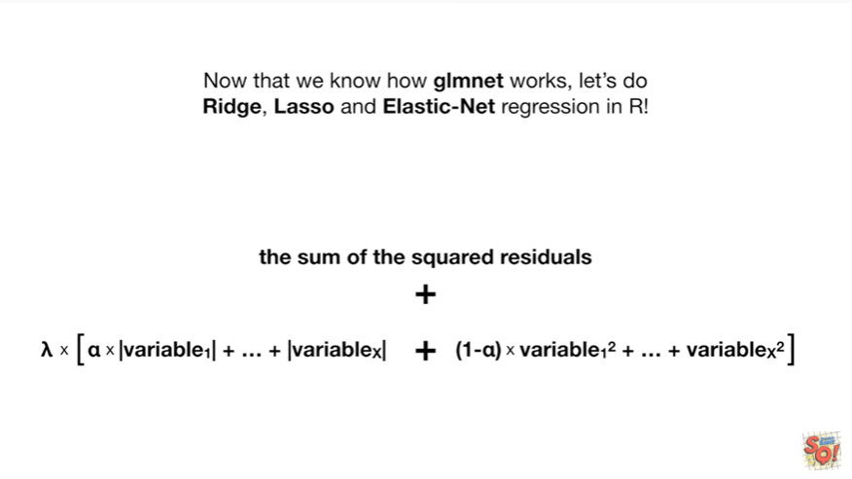

Now that we know how glmnet works, let's do ridge, lasso an elastic net regression in R.

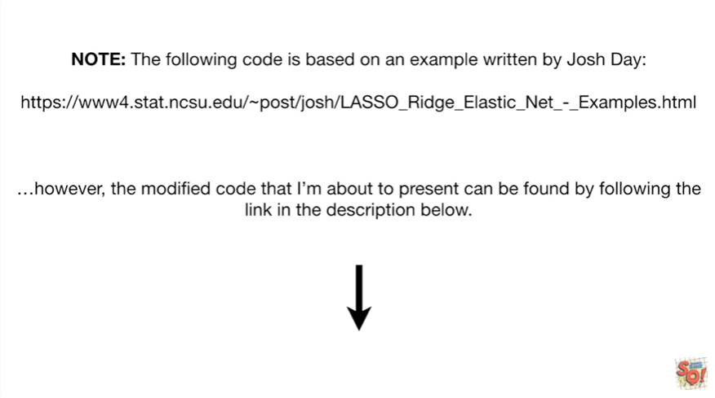

Note : the following code is based on an example written by Josh day however the modified code that I'm about to present can be found by following the link in the description below.

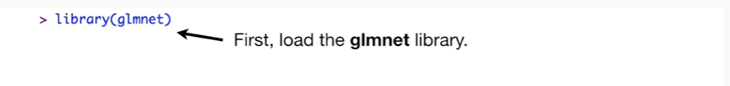

First load the glmnet library.

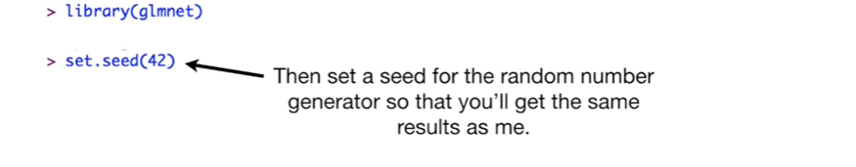

Then set a seed for the random number generator so that you'll get the same results as me.

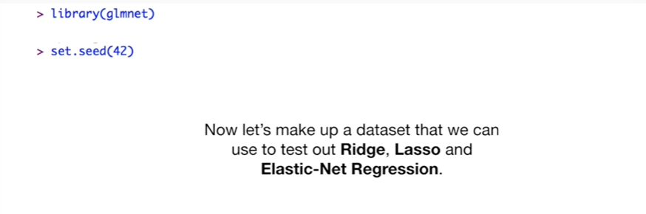

Now let's make up a data set that we can use to test out ridge, lasso and elastic net regression.

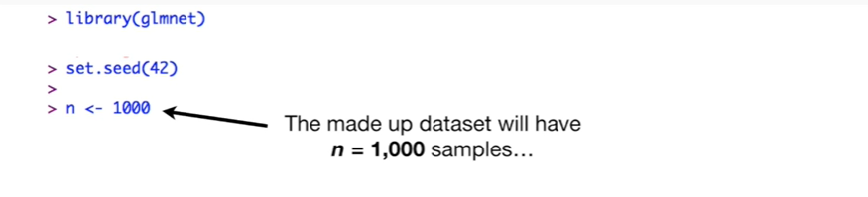

The made-up data set will have N equals 1,000 samples

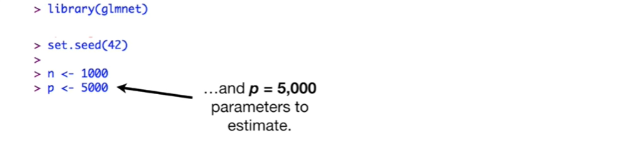

and P equals 5000 parameters to estimate.

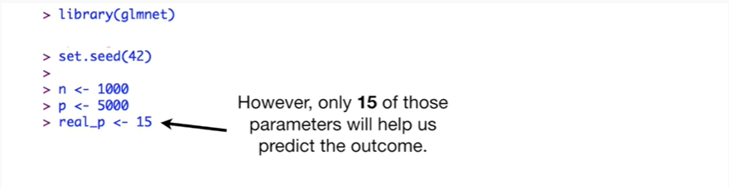

However only 15 of those parameters will help us predict the outcome.

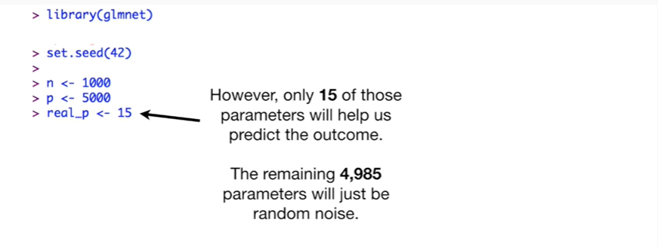

The remaining 4985 parameters will just be random noise.

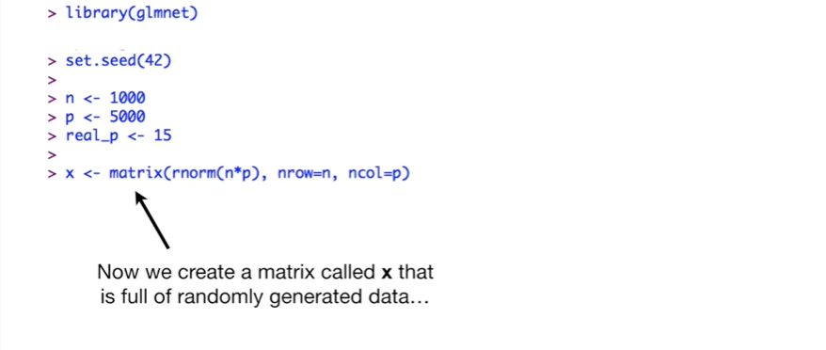

Now we create a matrix called X that is full of randomly generated data

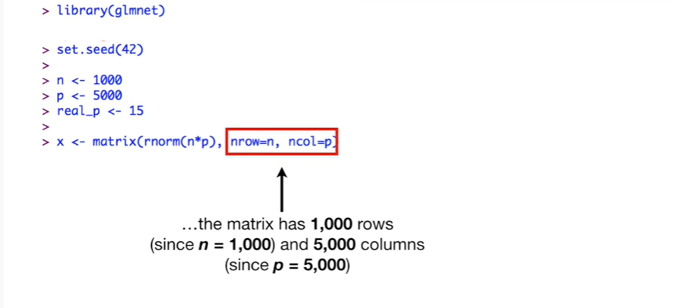

the matrix has 1,000 rows since n equals 1000 and 5000 columns since P equals 5,000

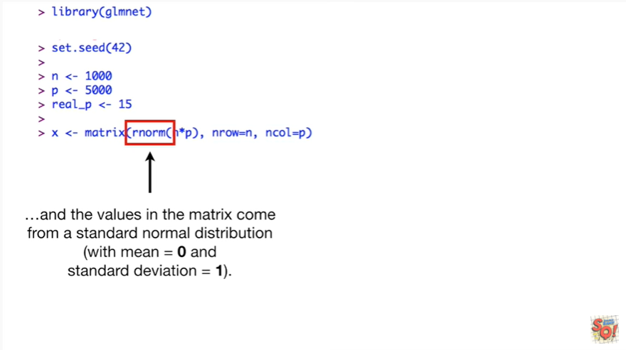

and the values in the matrix come from a standard normal distribution with mean equals zero and standard deviation equals one

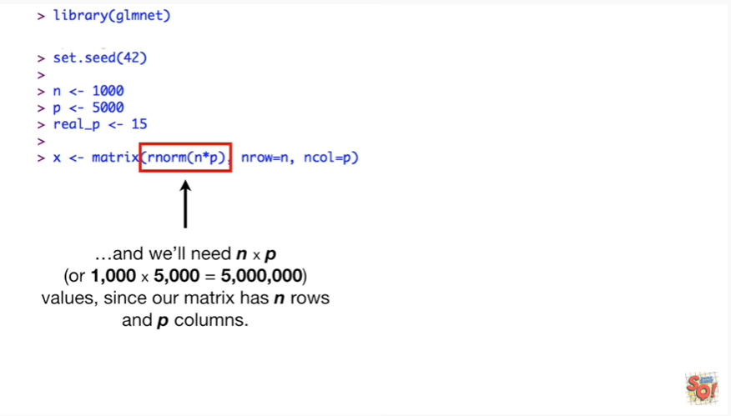

and we'll need n times P or one thousand times five thousand equals five million values since our matrix has n rows and P columns.

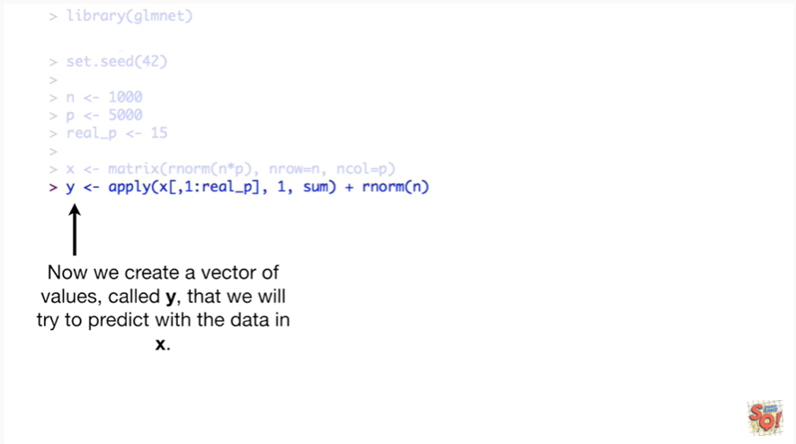

Now we create a vector of values called Y that we will try to predict with the data in X.

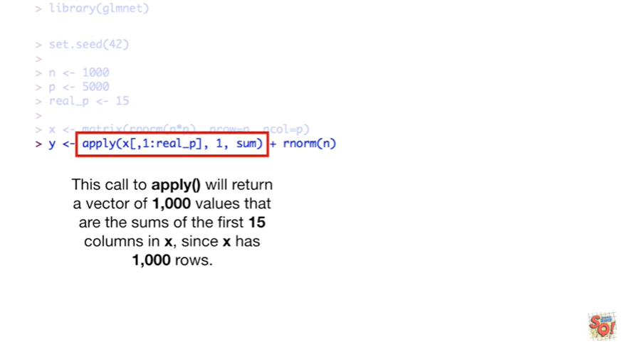

This call to apply will return a vector of 1000 values that are the sums of the first 15 columns and X since X has 1000 rows.

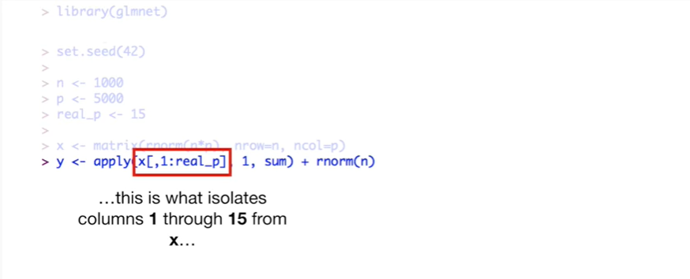

This is what isolates columns 1 through 15 from X

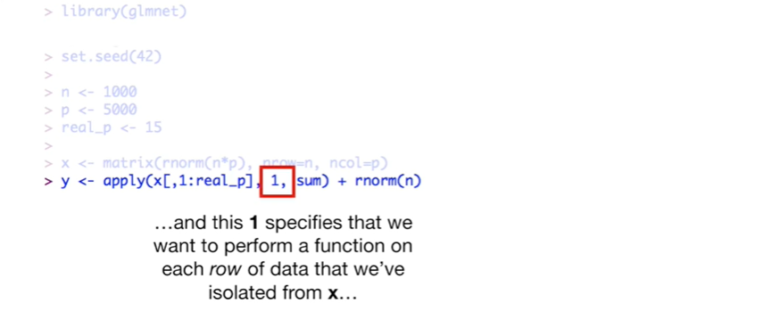

and this one specifies that we want to perform a function on each row of the data that we've isolated from X

and some is the function we want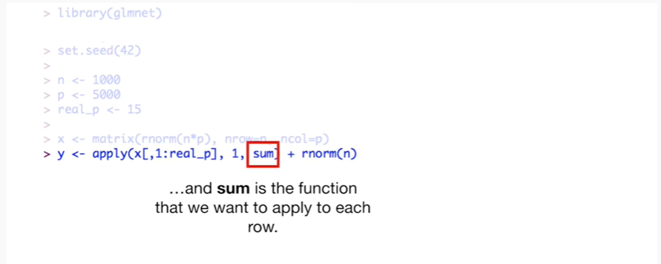 to apply to each row.

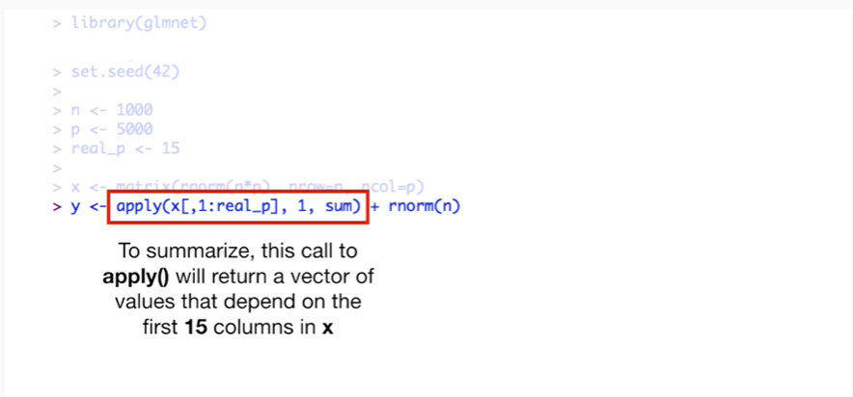

To summarize this call to apply will return a vector of values that depend on the first 15 columns in X.



Once we have that vector of Psalms we add a little bit of noise using the rnorm() function which in this case returns 1000 random values from a standard normal distribution.

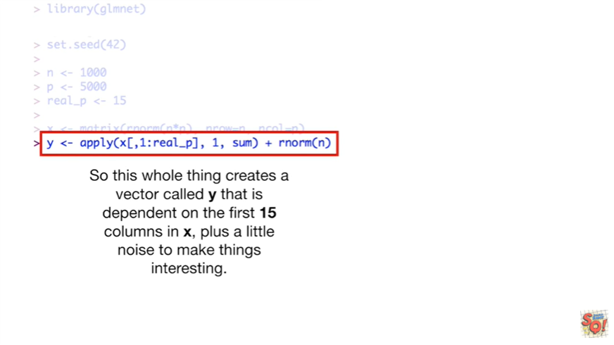

So this whole thing creates a vector called Y that is dependent on the first 15 columns in X plus a little noise to make things interesting.

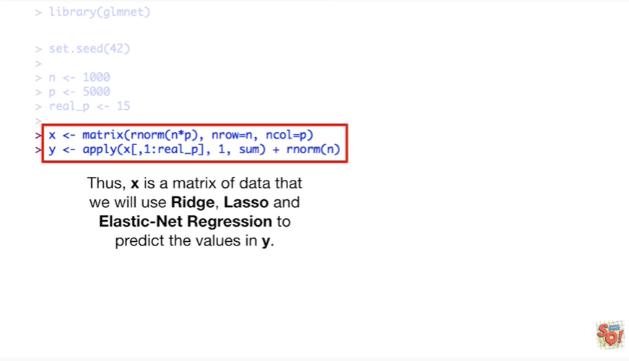

Thus X is a matrix of data that we will use ridge, lasso an elastic net regression to predict the values in y.

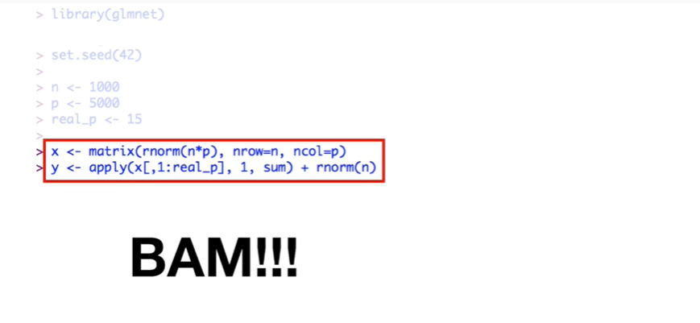

BAM !!!

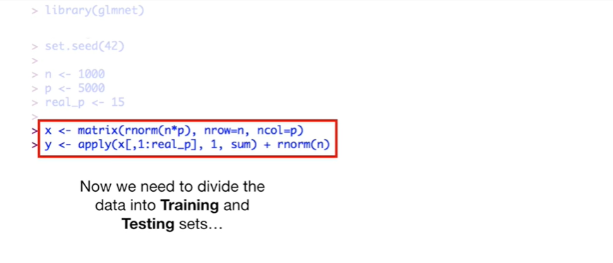

Now we need to divide the data into training and testing sets

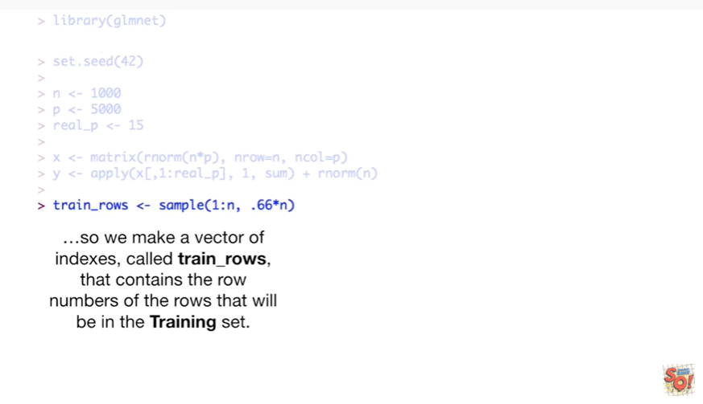

so we make a vector of indexes called Train underscore rows that contains the row numbers of the rows that will be in the training set.

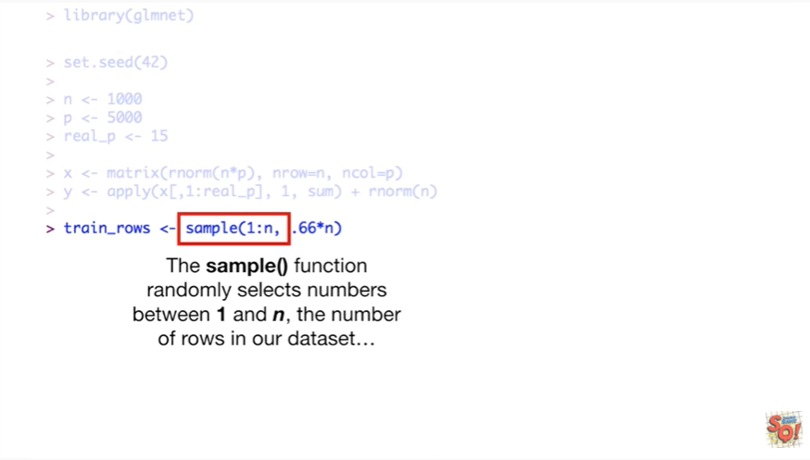

The sample function randomly selects numbers between 1 and n the number of rows in our data set

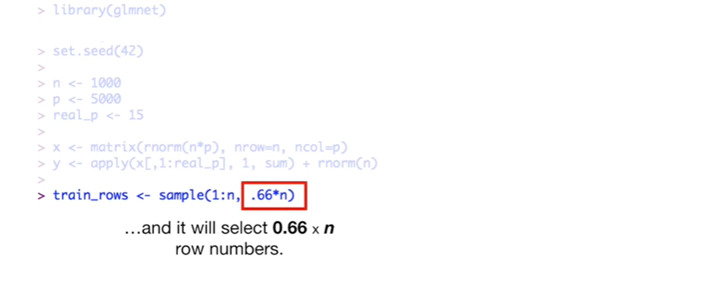

and it will select 0.66 x n row numbers.

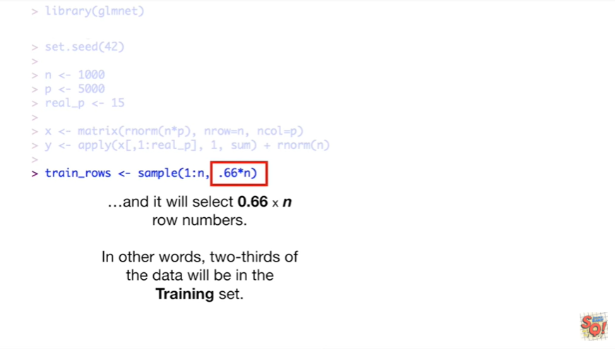

In other words two-thirds of the data will be in the training set.

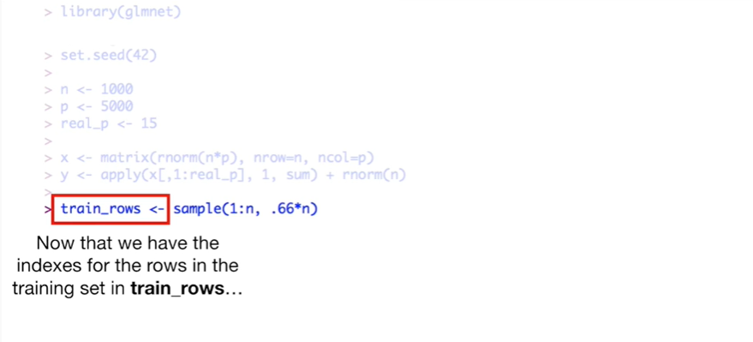

Now that we have the indexes for the rows in the training set in train underscore rows

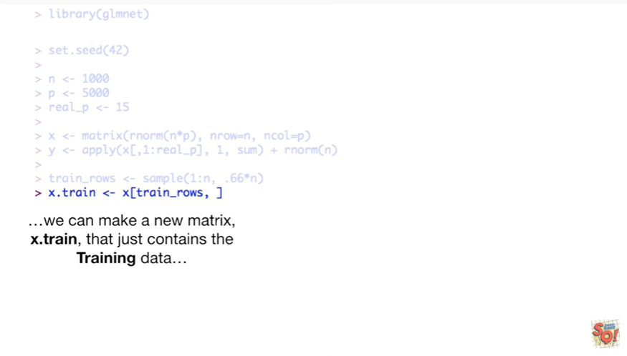

we can make a new matrix X dot train that just contains the training data

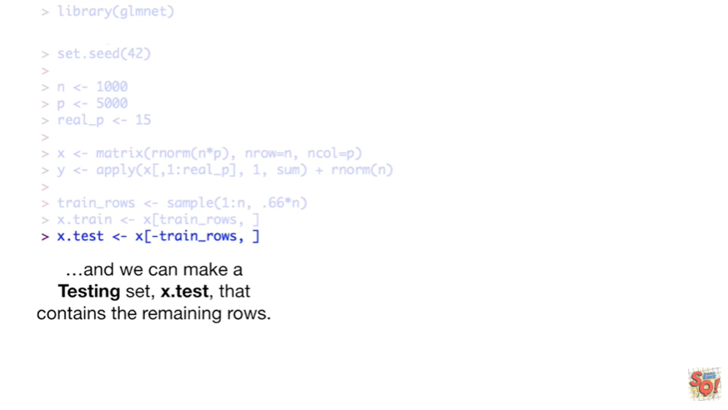

and we can make a testing set X dot test that contains the remaining rows.

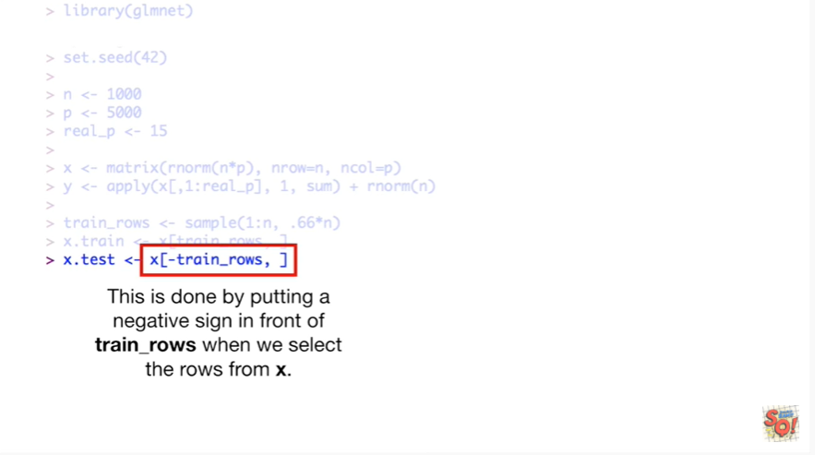

This is done by putting a negative sign in front of train underscore rows when we select rows from X.

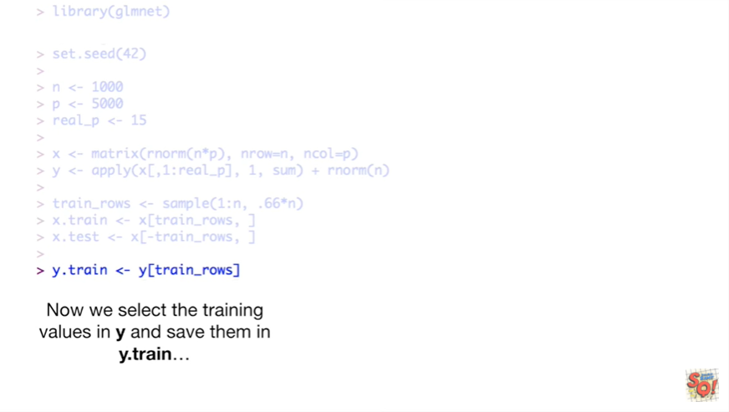

Now we select the training values in Y and save them in Y dot train

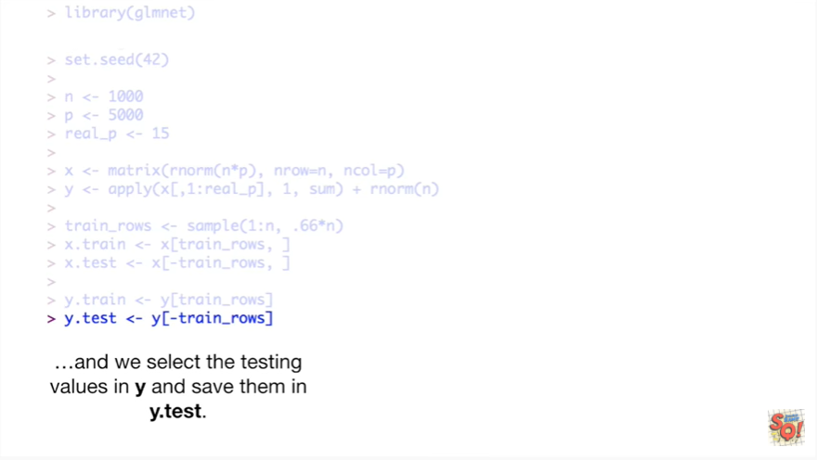

and we select the testing values in Y and save them in Y dot test.

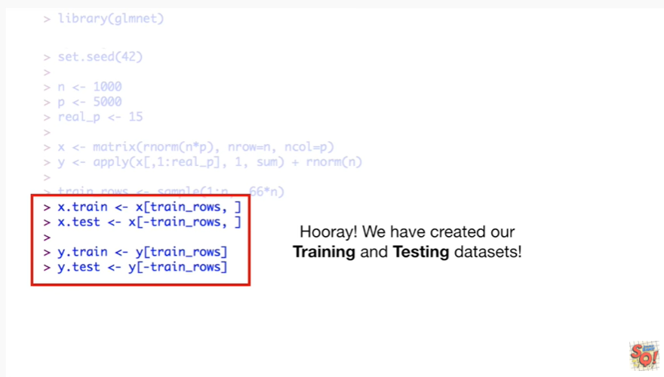

Hooray !

We've created our training and testing datasets.

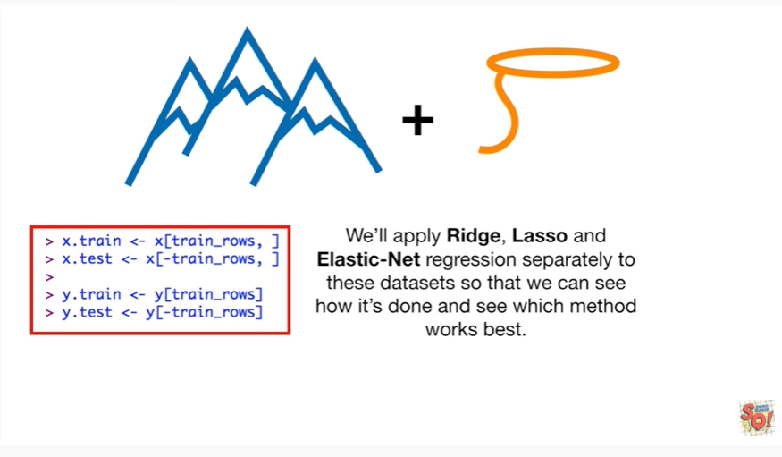

We’ll apply Ridge lasso an elastic net regression separately to these datasets so that we can see how it's done and see which method works best.

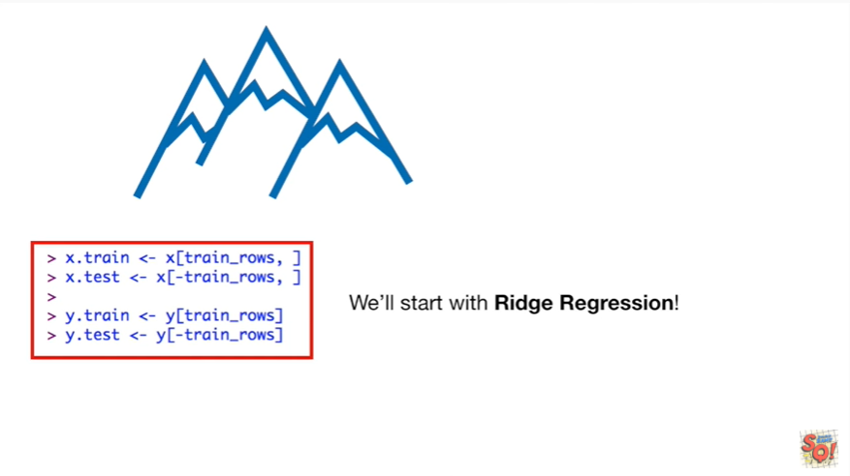

We'll start with Ridge regression.

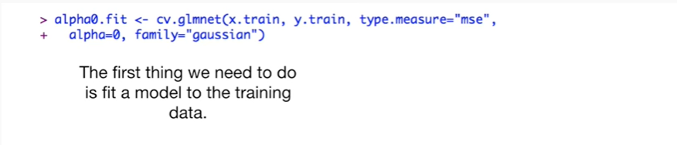

The first thing we need to do is fit a model to the training data.

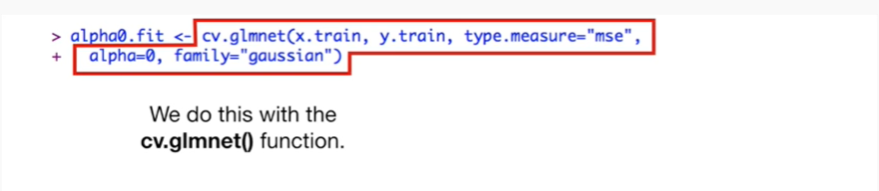

We do this with the cv.glmnet() function.

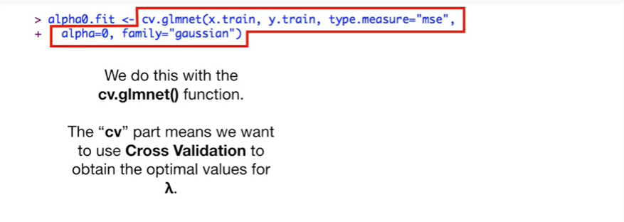

The ‘cv’ part means we want to use cross-validation to obtain the optimal values for lambda.

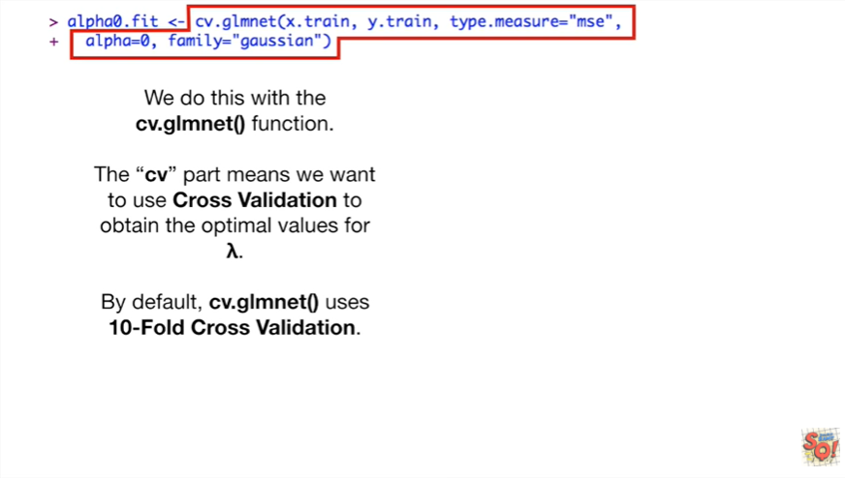

By default cv.glmnet() uses 10-fold cross-validation.

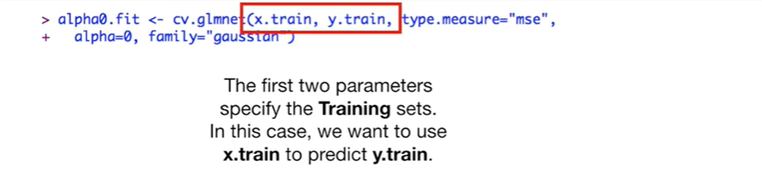

The first two parameters specified the training sets in this case we want to use X train to predict y train.

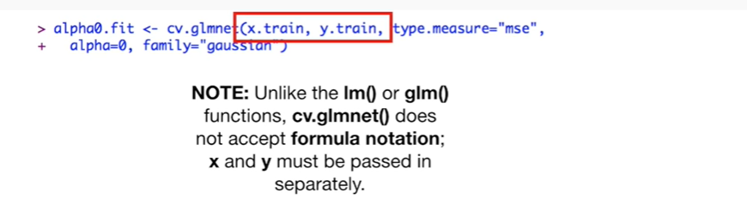

Note : unlike the lm() or glm() functions, cv.glmnet() does not accept formula notation ; x and y must be passed in separately.

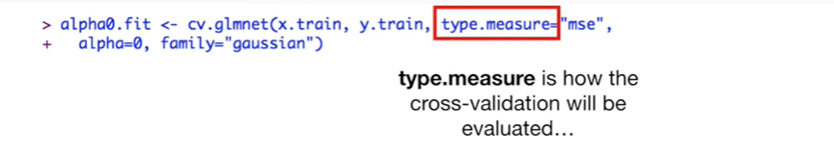

Type dot measure is how the cross-validation will be evaluated

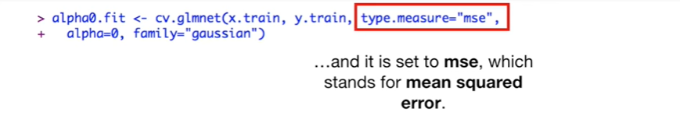

and it is set to MSE which stands for mean squared error.

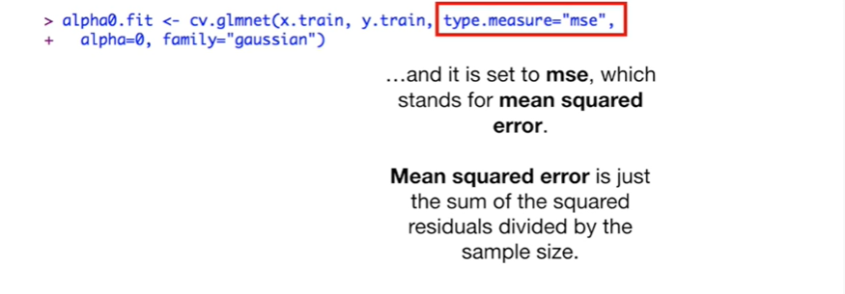

Mean squared error is just the sum of the squared residuals divided by the sample size.

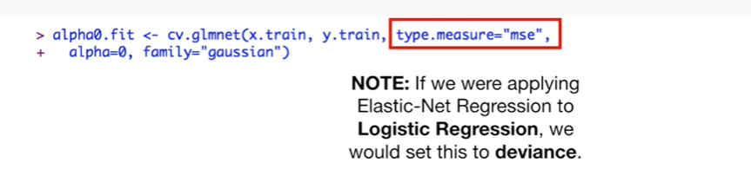

Note : if we are applying elastic net regression to logistic regression then we would set this to deviance.

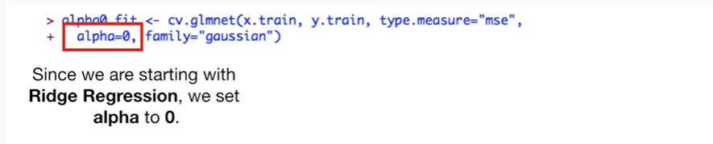

Since we are starting with Ridge regression we set alpha to zero.

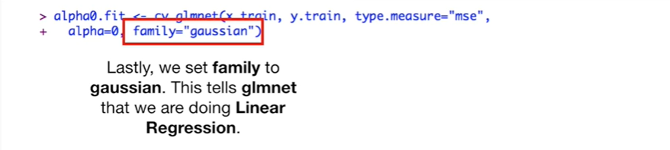

Lastly we set family to Gaussian.

This tells glmnet() that we are doing linear regression.

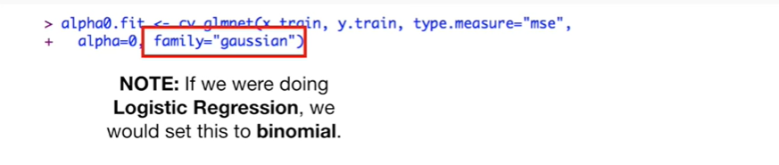

Note : if we were doing logistic regression we would set this to binomial.

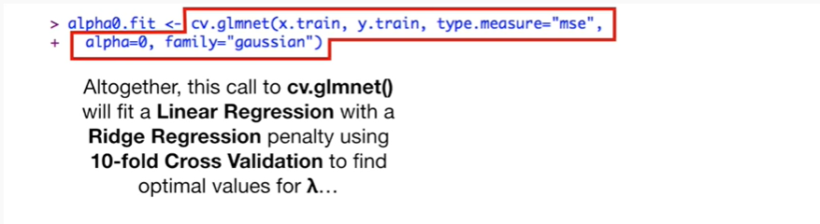

Altogether this called a cv.glmnet() will fit a linear regression with a Ridge regression penalty using 10-fold cross-validation to find optimal values for lambda.

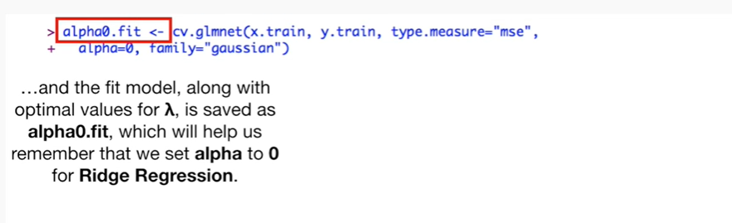

and the fit model along with optimal values for lambda is saved as alpha 0 dot fit which will help us remember that we set alpha to 0 for ridge regression.

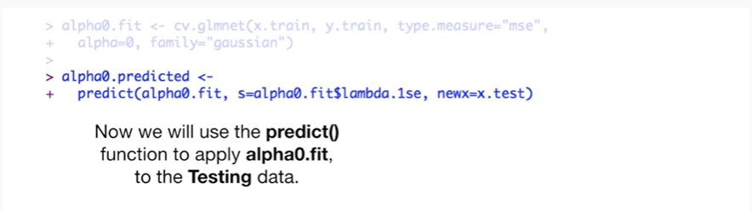

Now we will use the predict function to apply alpha zero da fit to the testing data.

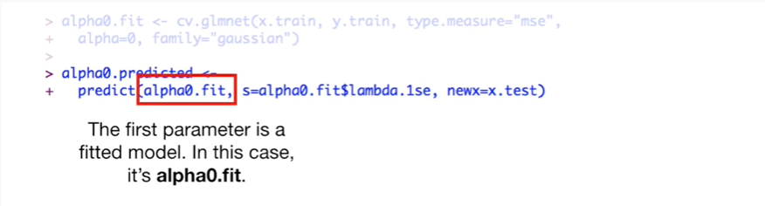

The first parameter is a fitted model in this case it's alpha0.fit.

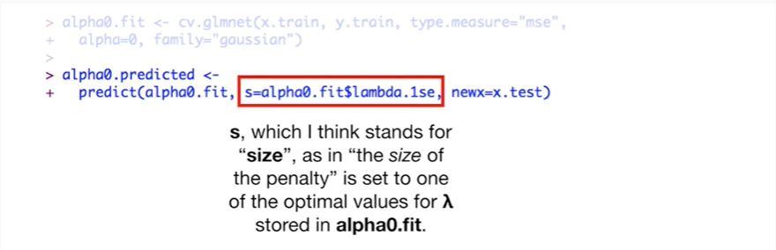

S which I think stands for size as in the size of the penalty is set to one of the optimal values for lambda stored an alpha 0 dot fit.

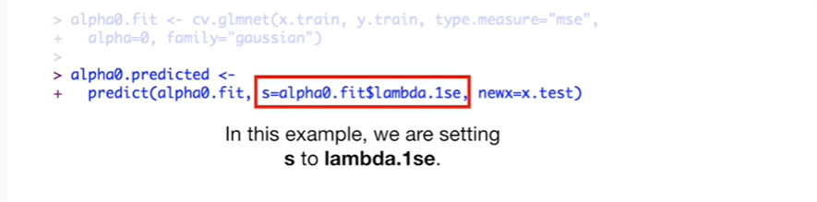

In this example we're setting s to lambda dot 1 se.

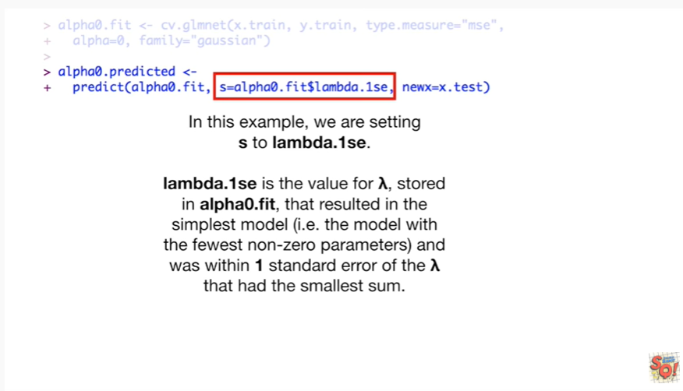

Lambda dot 1 se is the value for lambda stored an alpha 0 dot fit that resulted in the simplest model ie the model with the fewest non-zero parameters and was within 1 standard error of the lambda that had the smallest sum.

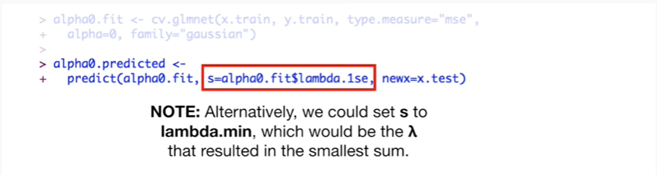

Note : alternatively we could set s to lambda dot min which would be the lambda that resulted in the smallest sum.

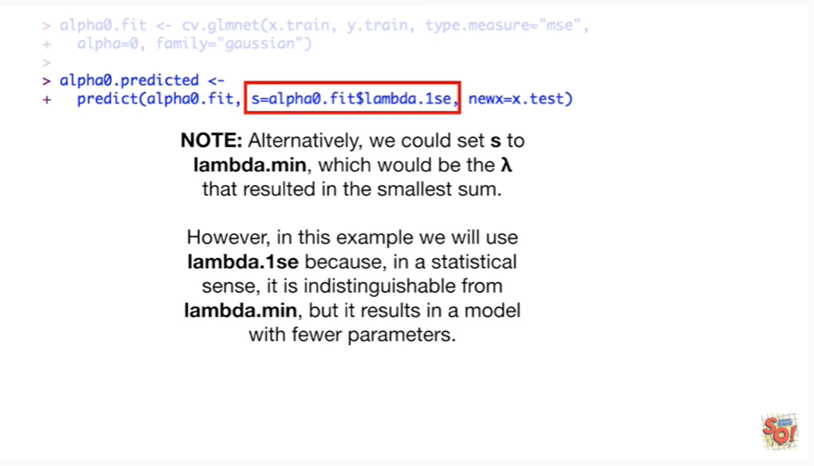

However in this example we would use lambda dot 1 s e because in a statistical sense it is indistinguishable from lambda dot min but it results in a model with fewer parameters.

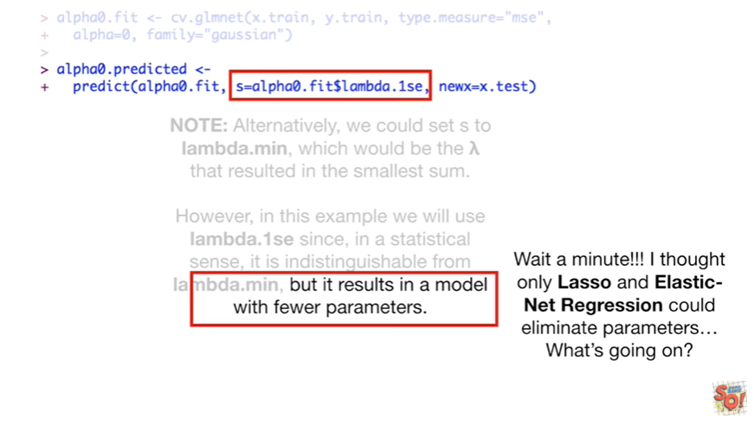

Wait a minute !!!

I thought only last so an elastic net regression could eliminate parameters what's going on ?

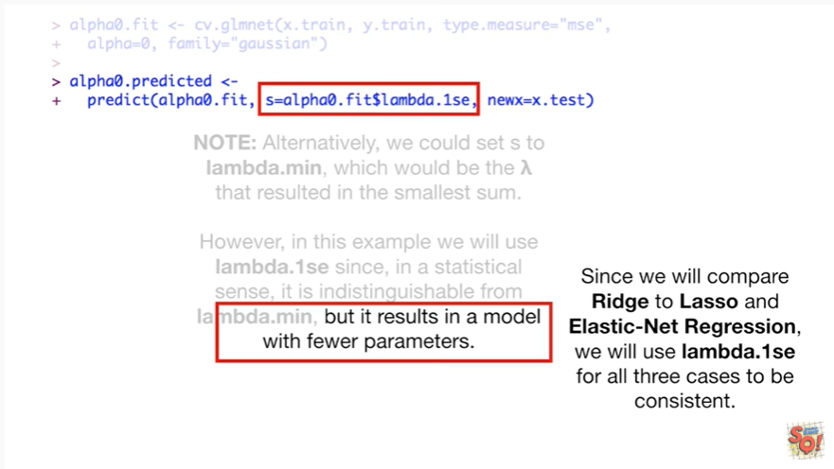

Since we will compare Ridge to lasso and elastic net regression, we will use lambda dot one se for all three cases to be consistent.

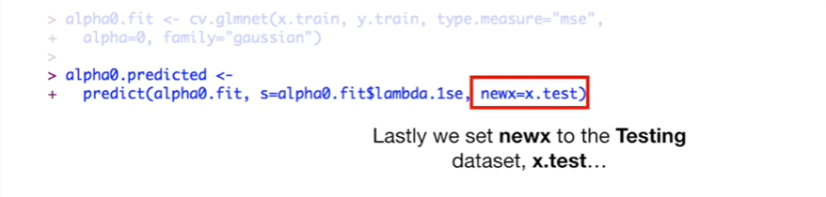

Lastly we set new X to the testing data set X dot test

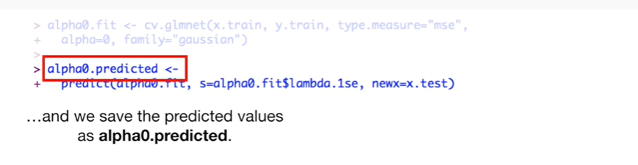

and we save the predicted values as alpha 0 dot predicted.

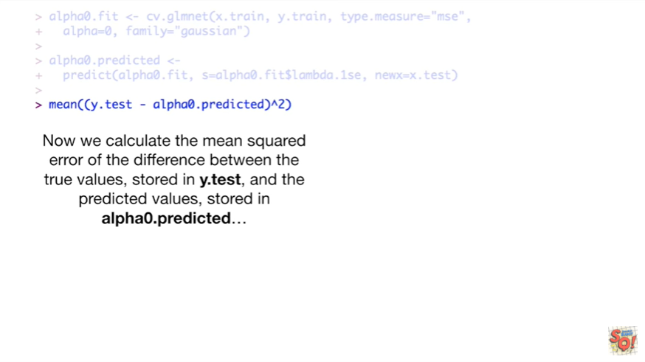

Now we calculate the mean squared error of the difference between the true values stored in a y.test and the predicted values stored in alpha0.predicted

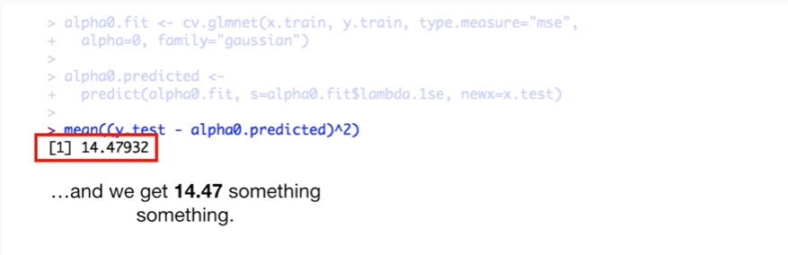

and we get fourteen point four seven something something.

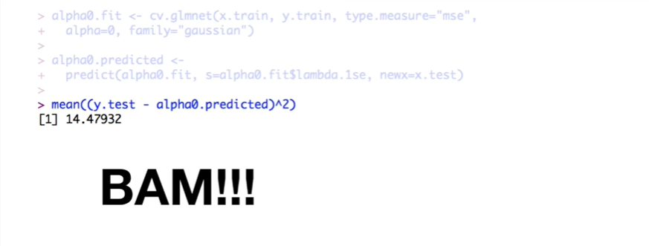

BAM !!!

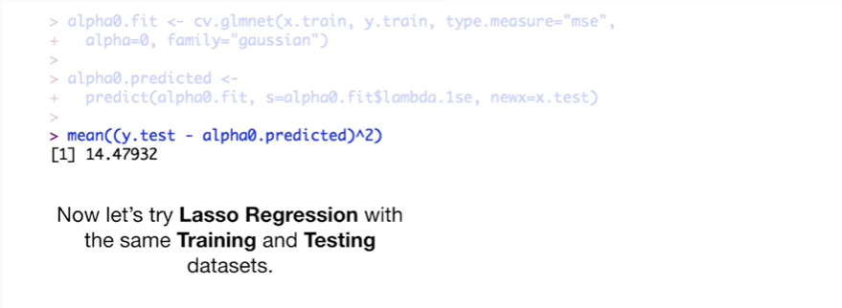

Now let's try lasso regression with the same training and testing datasets.

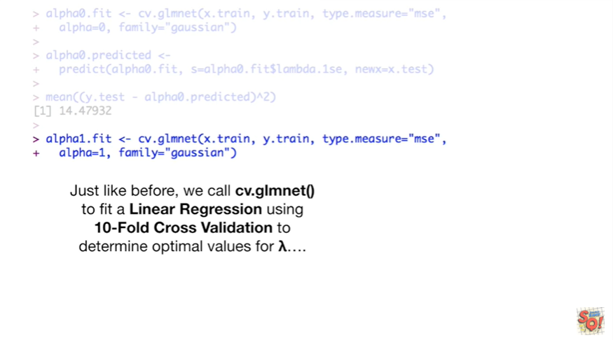

Just like before we call cv.glmnet() to fit a linear regression using 10-fold cross-validation to determine optimal values for lambda

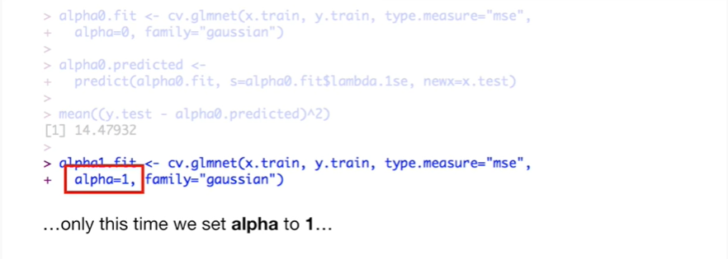

only this time we set alpha to 1

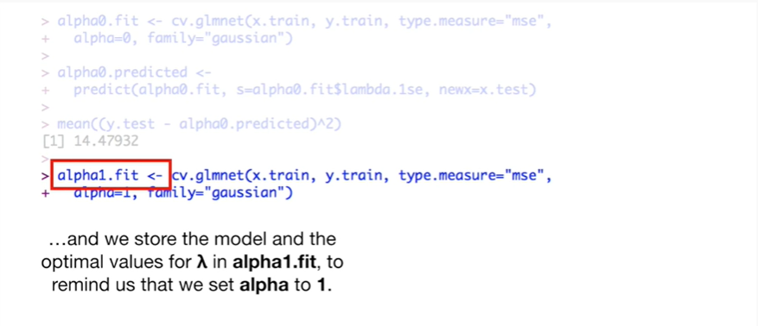

and we will store the model and the optimal values for lambda in alpha one fit to remind us that we set alpha to 1.

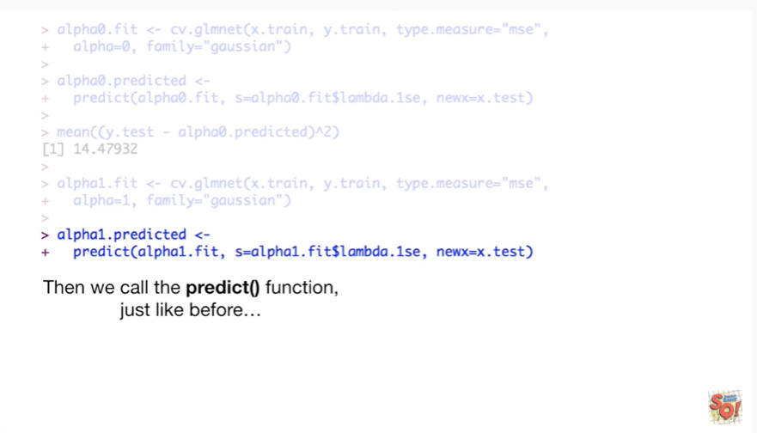

Then we call the predict function just like before

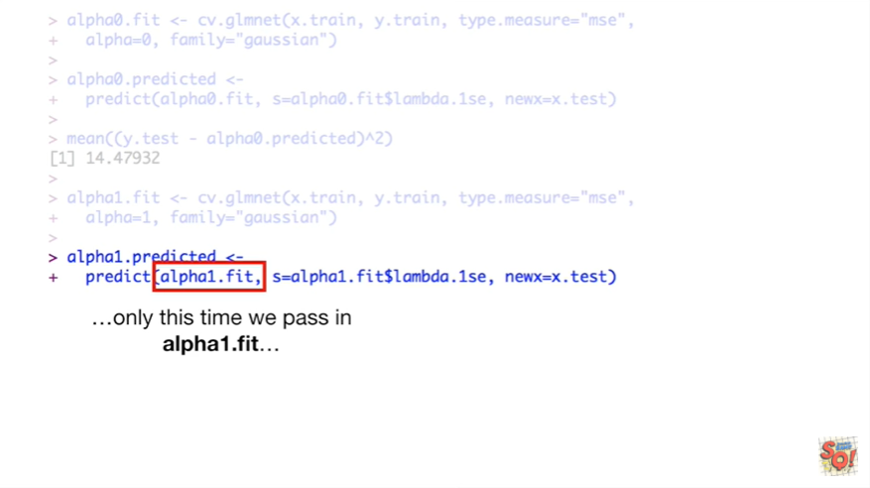

only this time we pass an alpha 1 dot fit

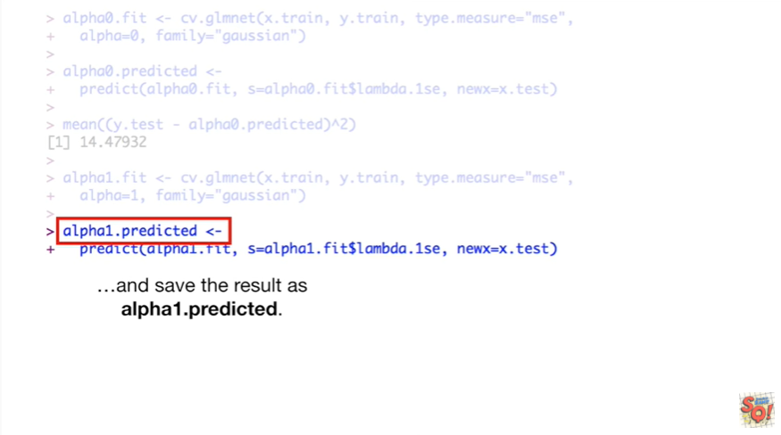

and save the results as alpha 1 dot predicted.

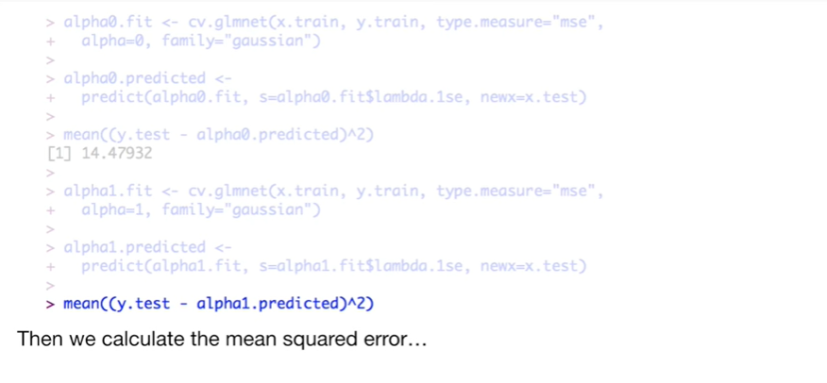

Then we calculate the mean squared error

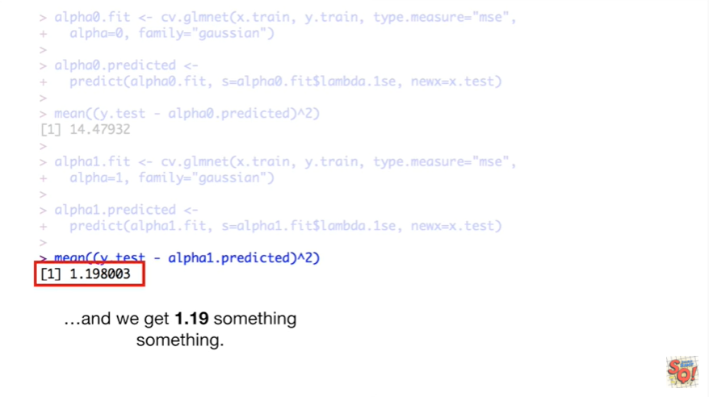

and we get one point one nine something something.

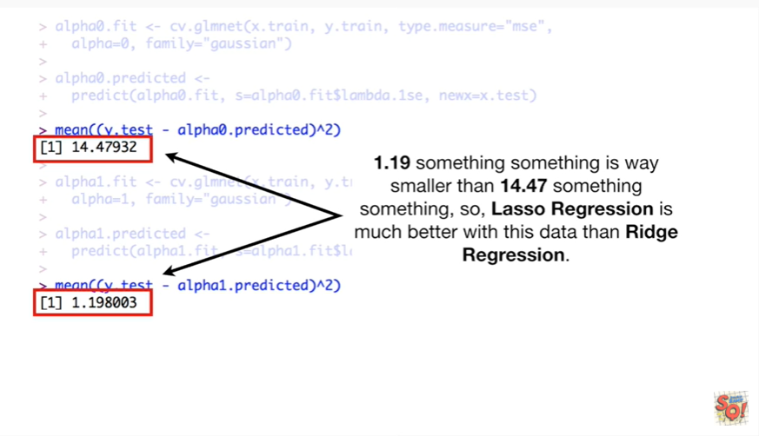

One point one nine something something is way smaller than fourteen point four seven something something so Lasser regression is much better with this data than Ridge regression.

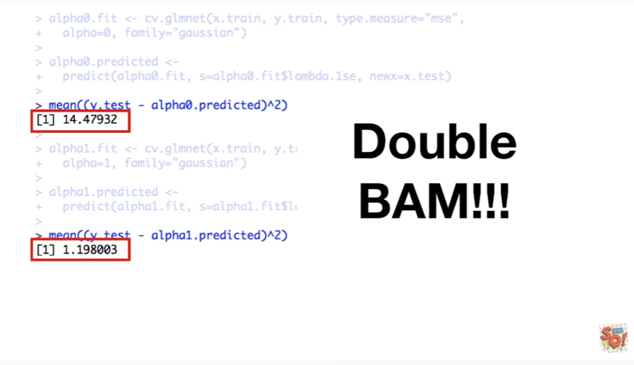

Double bam !!!

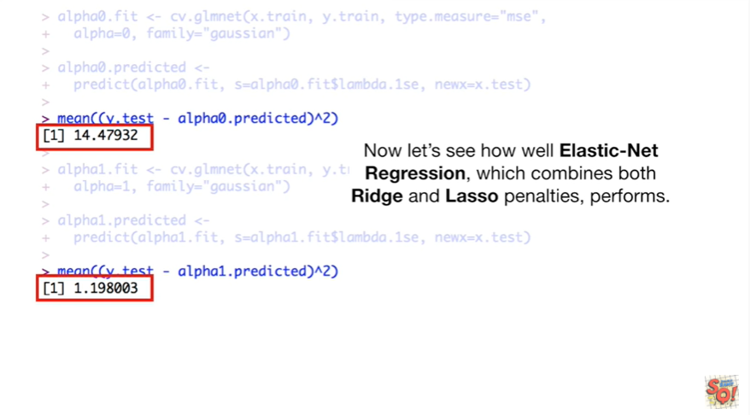

Now let's see how well elastic net regression which combines both Ridge and lasso penalties performs.

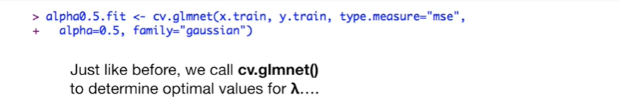

Just like before we call CV GL and net to determine optimal values for lambda

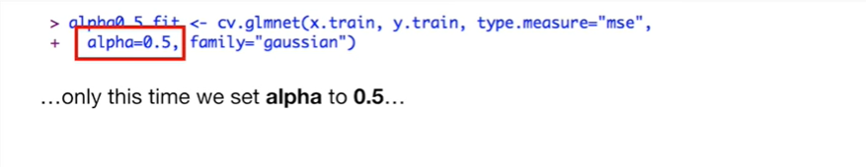

only this time we set alpha to 0.5

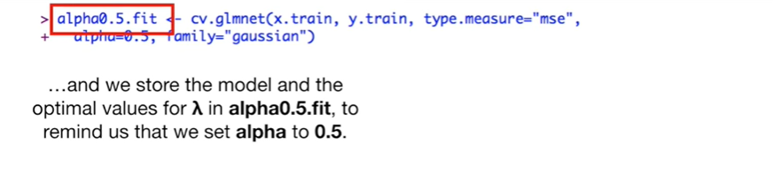

and we store the model and the optimal values for lambda in alpha 0.5 dot fit to remind us that we set alpha to 0.5.

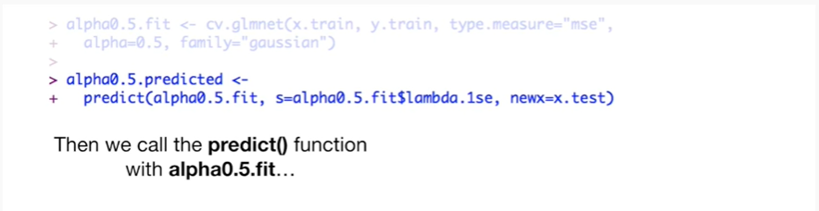

Then we call the predict function with alpha 0.5 dot fit

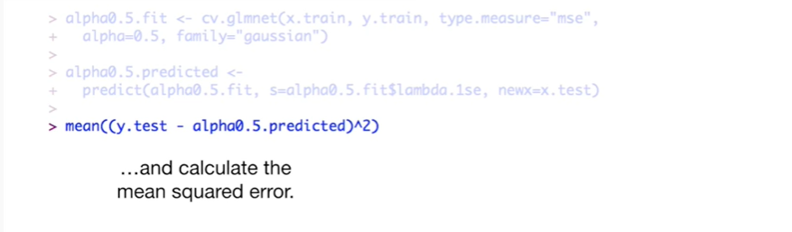

and calculate the mean squared error

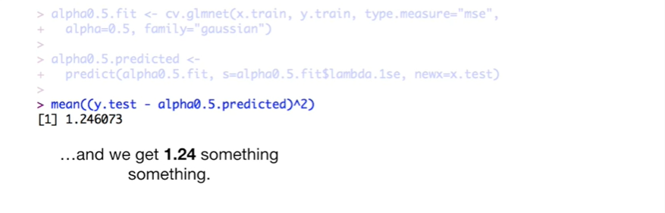

and we get 1.2 for something something.

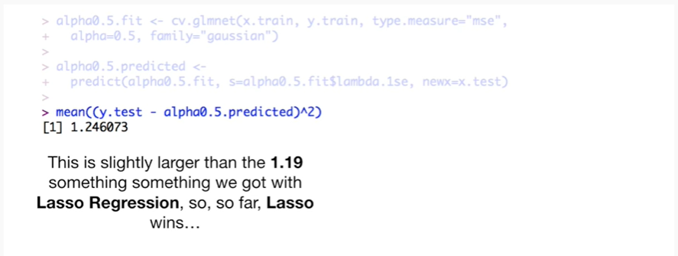

This is slightly larger than the 1.19 something something we got with lasso regression so so far lasso wins

Yeehaw.

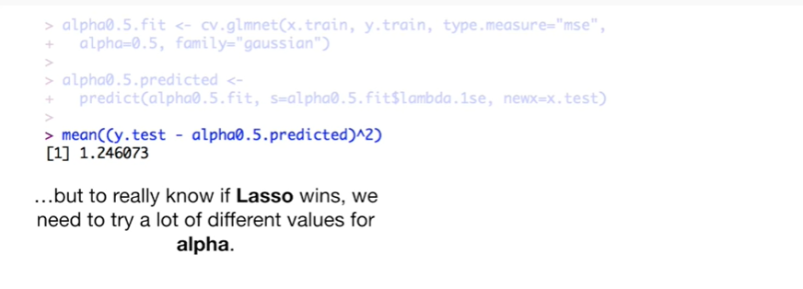

But to really know if lasso wins we need to try a lot of different values for alpha.

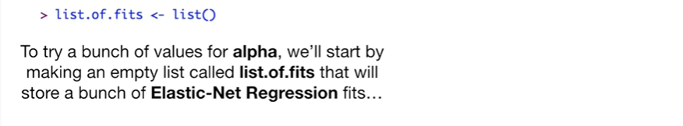

To try a bunch of values for alpha we'll start by making an empty list called list of fits that will store a bunch of elastic net regression fits.

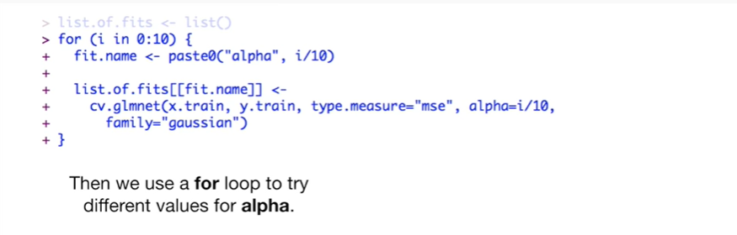

Then we use a for loop to try different values for alpha.

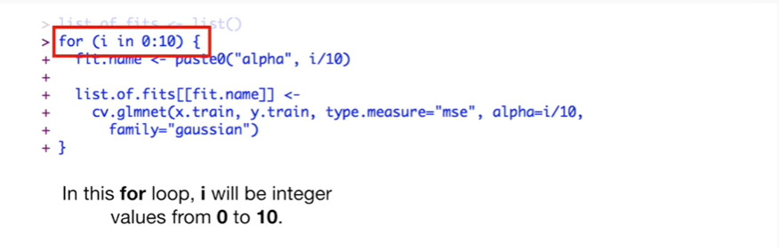

In this for loop I will be integer values from 0 to 10.

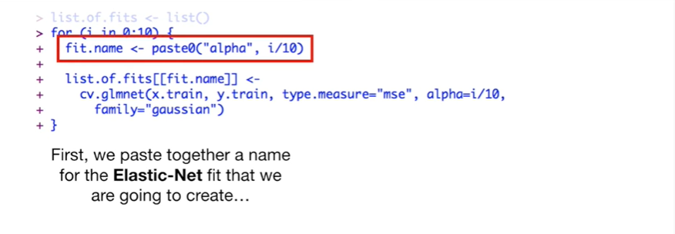

First we paste together a name for the elastic net fit that we are going to create.

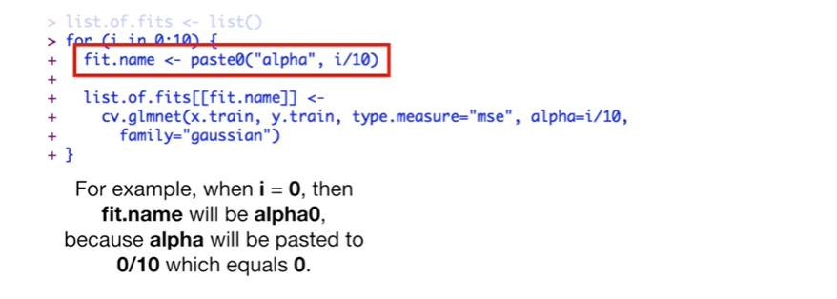

For example when I equals 0 then fit dot name will be alpha 0 because alpha will be pasted to 0 divided by 10 which equals 0.

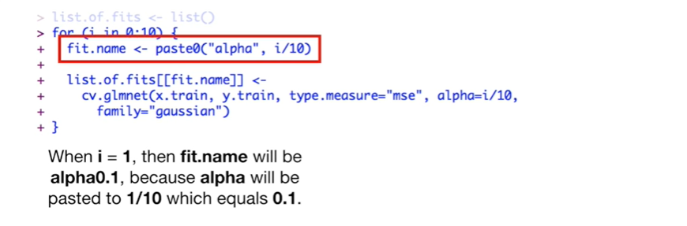

When I equals one then fit name will be alpha 0.1 because alpha will be pasted to 1/10 which equals 0.1.

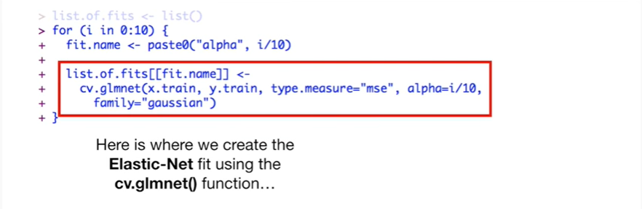

Here's where we create the elastic net fit using the cv.glmnet()t function.

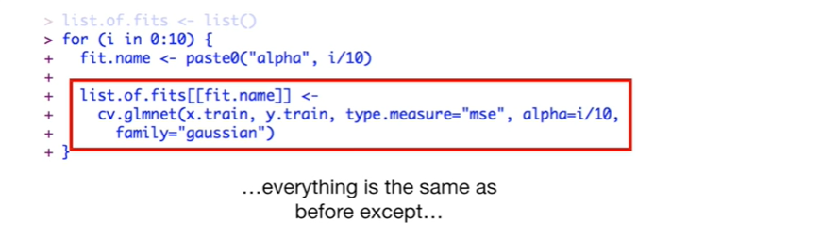

everything is the same as before except

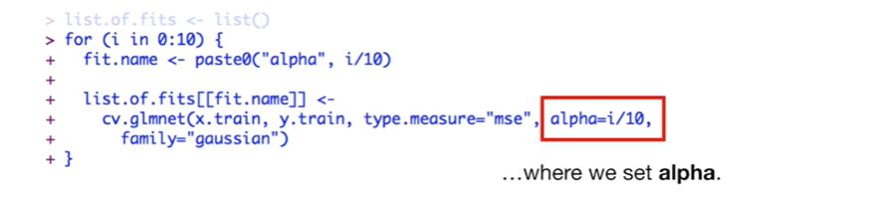

where we set alpha.

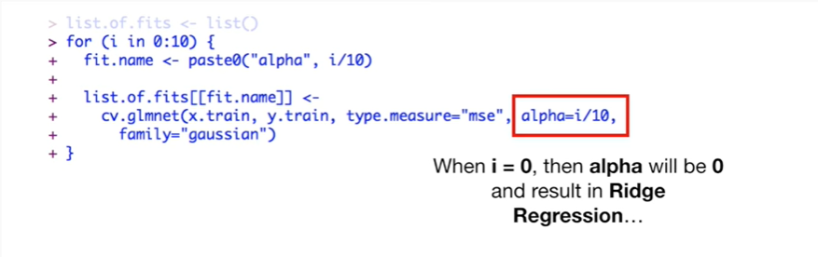

Xhen I equals 0 then alpha will be zero and result in Ridge regression

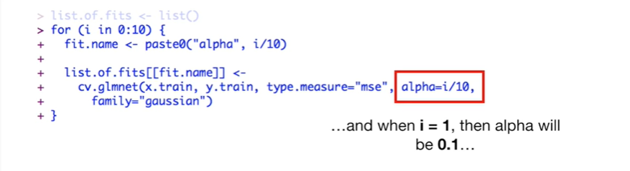

and when I equals 1 then alpha will be 0.1

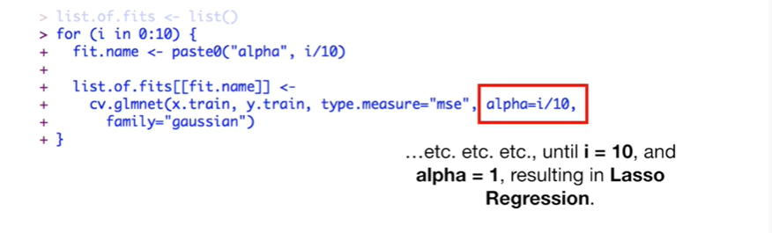

etc etc etc until I equals 10 and alpha equals 1 resulting in lasso regression.

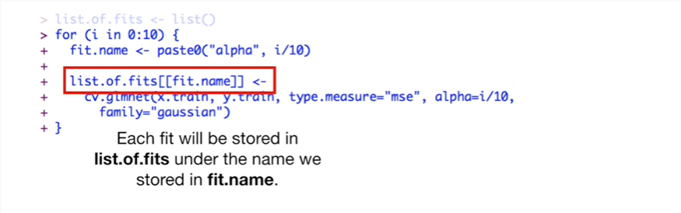

Each fit will be stored in a list of fits under the name we stored in fit dot name.

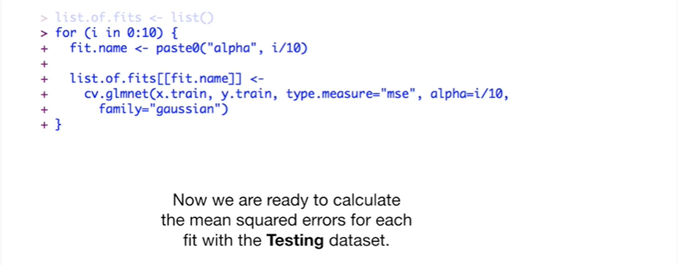

Now we are ready to calculate the mean squared errors for each fit with the testing data set.

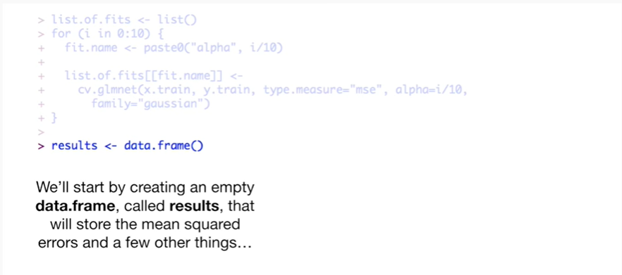

We'll start by creating an empty data frame called results that will store the mean squared errors and a few other things

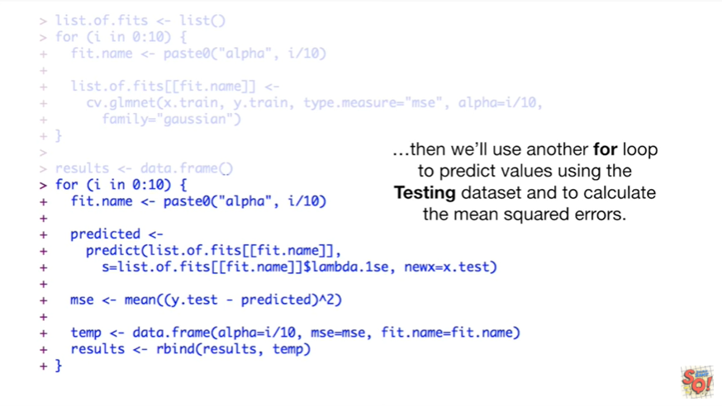

then we'll use another for loop to predict values using the testing data set to calculate the mean squared errors.

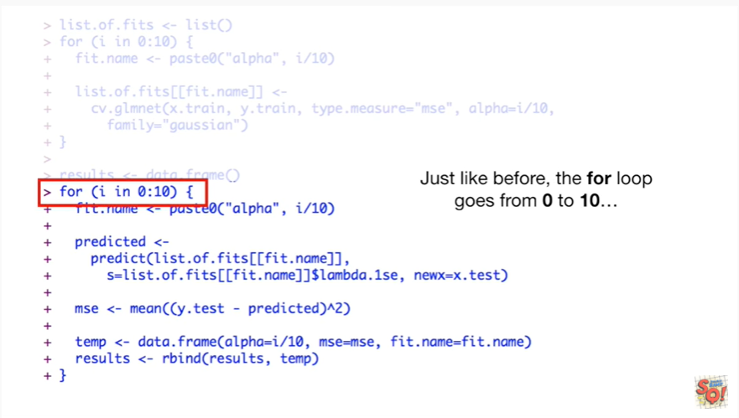

Just like before the for loop goes from zero to ten

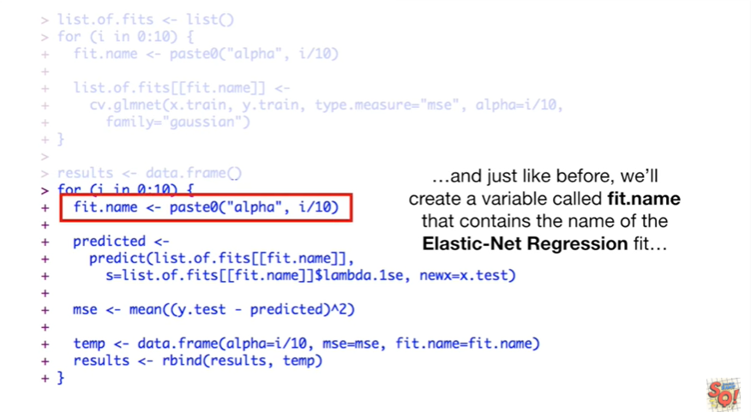

and just like before we'll create a variable called fit name that contains the name of the elastic net regression fit.

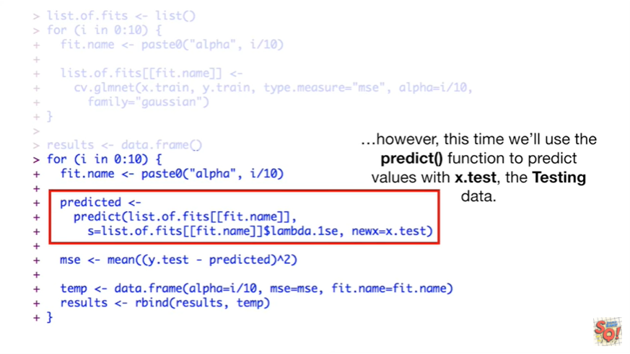

However this time we'll use the predict function to predict values with X dot test the testing data.

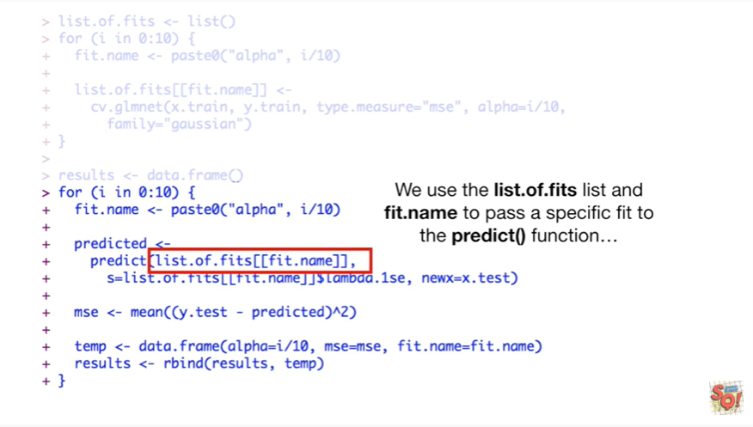

We use the list of fits list and fit dot name to pass a specific fit to the predict function

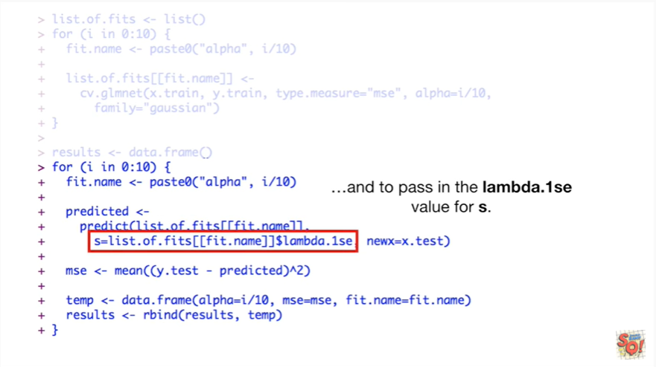

and to pass the lambda dot one se value for S.

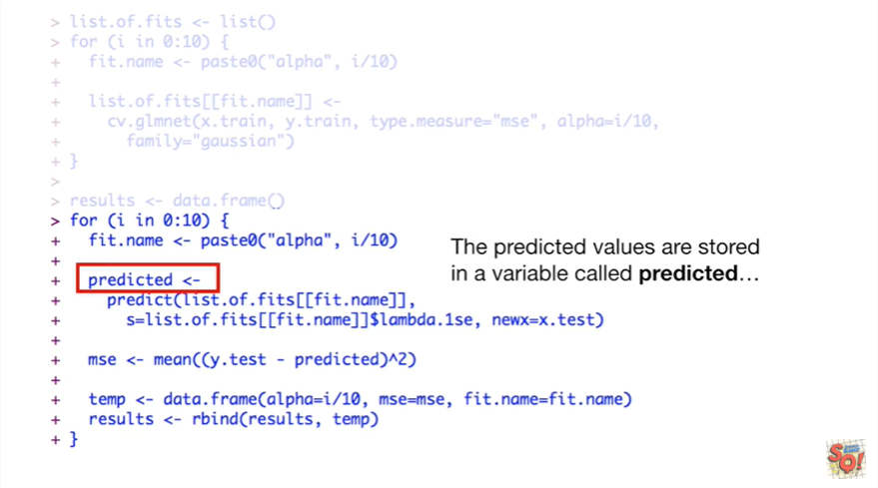

The predicted values are stored in a variable called predicted

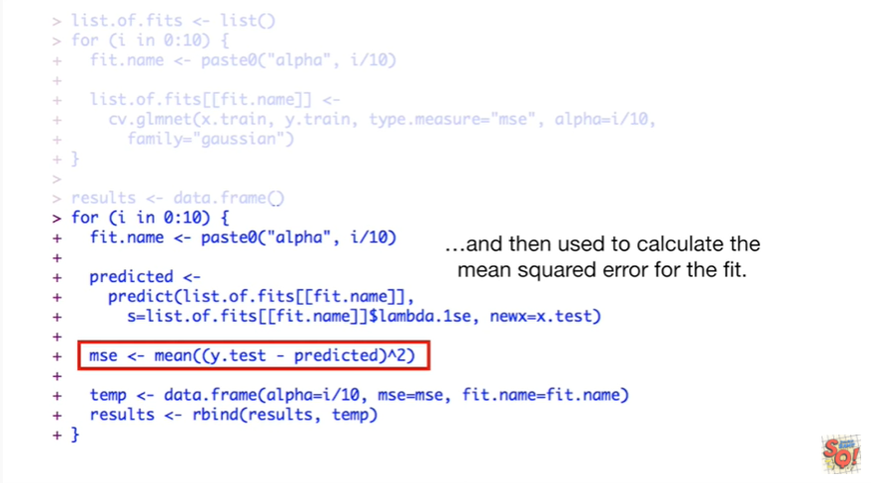

and then used to calculate the mean squared error for the fit.

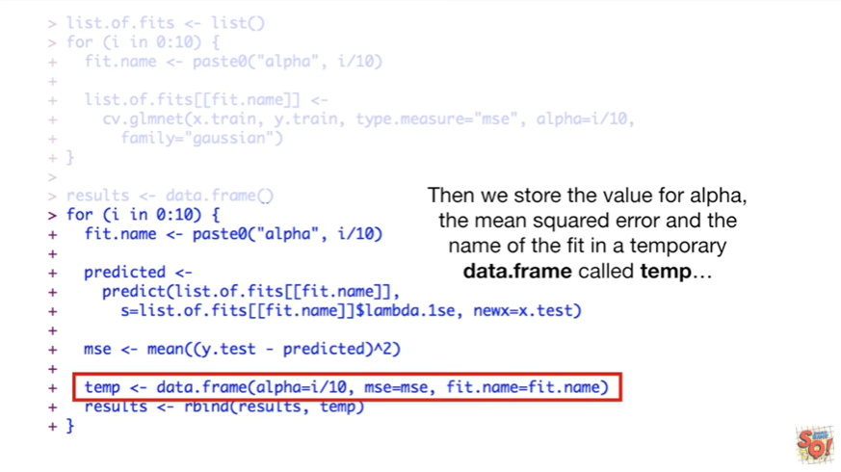

Then we store the value for alpha the mean squared error and the name of the fit in a temporary data frame called temp

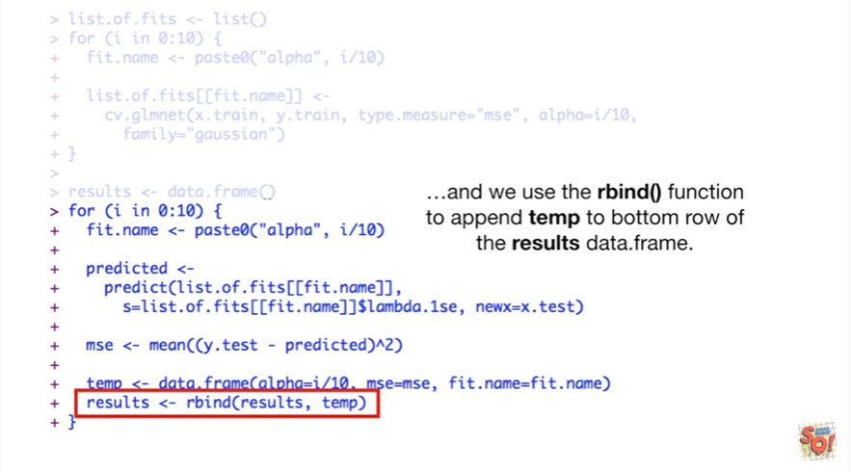

and we use the rbind() function to append temp to the bottom row of the results data frame.

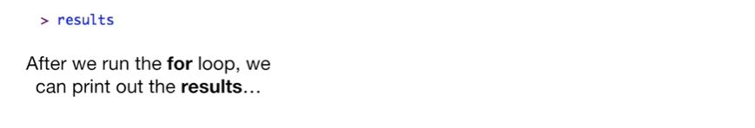

After we run the for-loop we can print out the results.

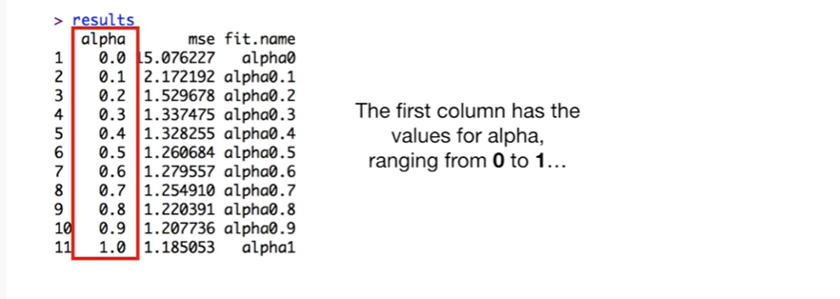

The first column has the values for alpha ranging from zero to one

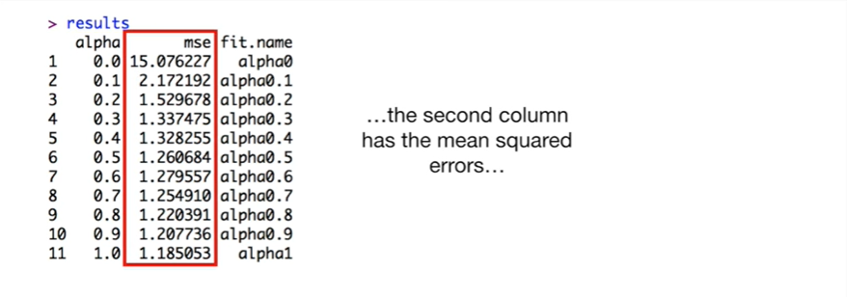

the second column has the mean squared errors.

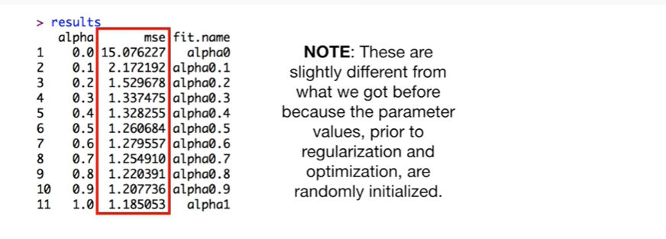

Note : these are slightly different from what we got before because the parameter values prior to regularization and optimization are randomly initialized.

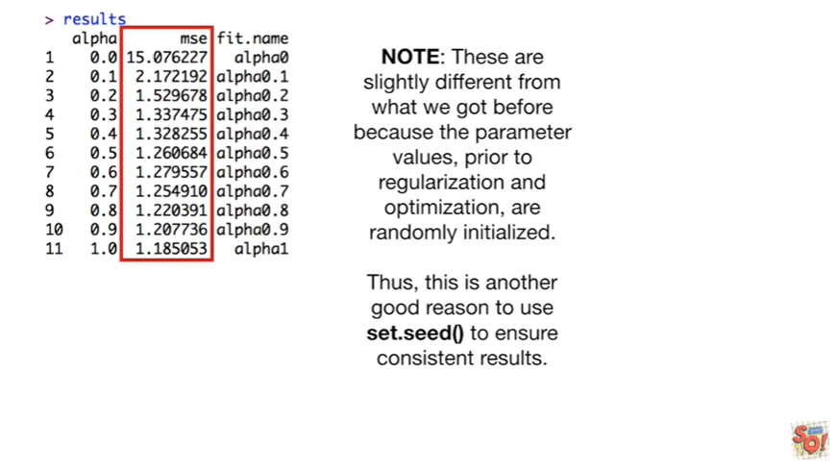

Thus this is another good reason to use set seed to ensure consistent results.

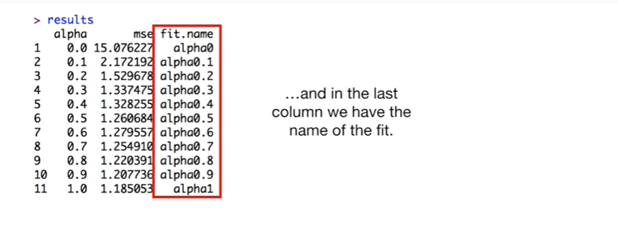

And in the last column we have the name of the fit.

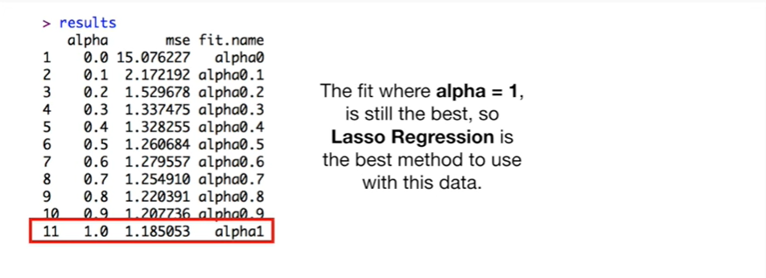

The fit where alpha equals 1 is still the best, so Lasser regression is the best method to use with this data.

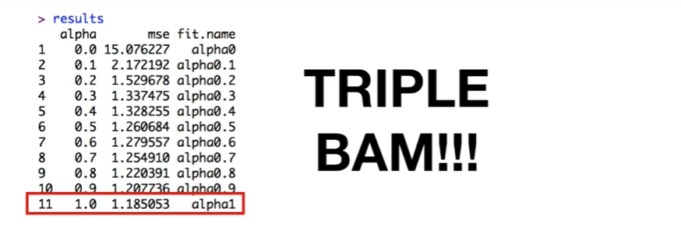Triple bam !!!